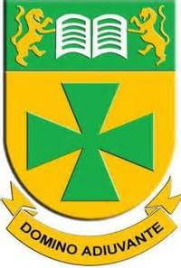
St Bede's
History Department

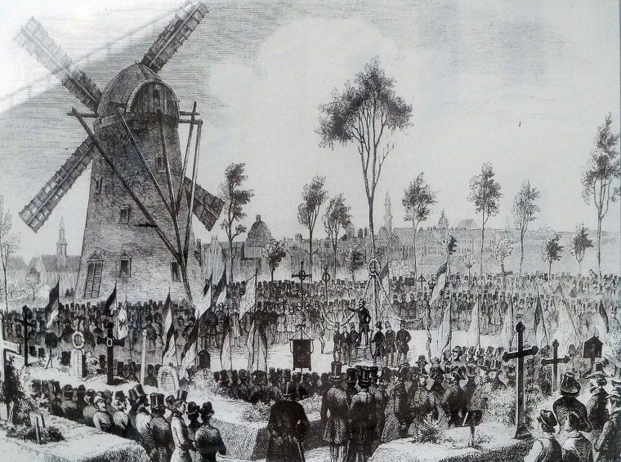
Year 8 Revision Book

British and other Empires
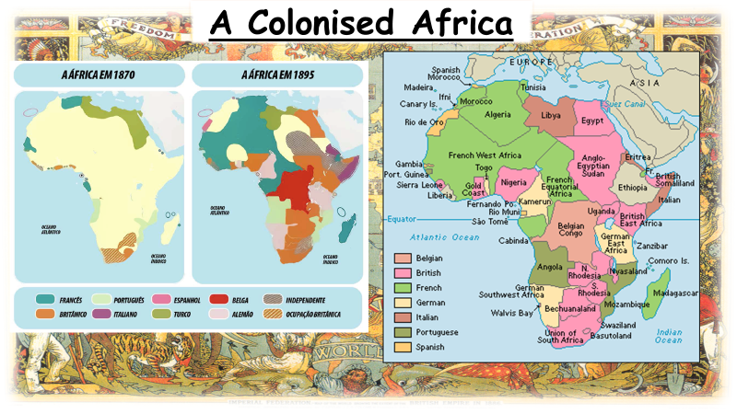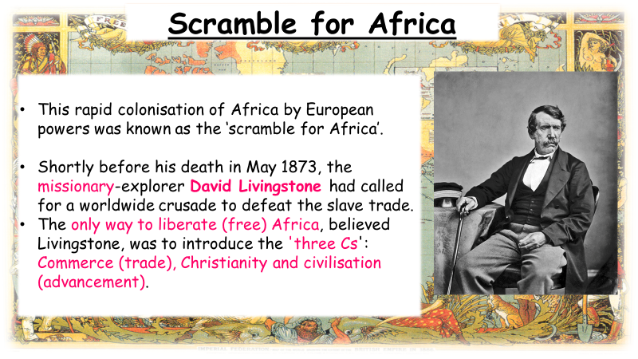
Enlightenment
- The Age of Discovery took place from the early 15th-late 17th century.
- During this time, European ships travelled around the world in search of new trading routes, partners and goods (such as gold, silver and spices).
- During this time, Europeans met people and mapped lands previously unknown to them.
- This was largely focused on the ‘New World’ (America)
- Slavery was an impact of this (which continued through the Enlightenment)
- British, French, Dutch, Spanish and Portuguese competed against each other to gain land

The Second Age of Discovery

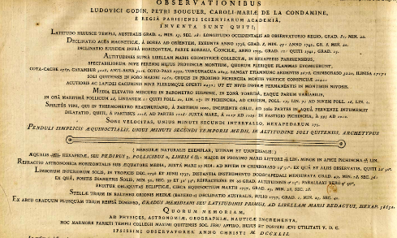
Equator:
- I n 1735, the French Academy of Sciences and French King Louis XV sent a voyage of scientists to the Equator.
- Their aim was to measure the roundness of the earth and measure the length of a degree of latitude at the Equator.
- This was the world’s first major international scientific expedition.
- The expedition’s results were published in maps, journals and official reports back in Europe.

Pacific Ocean:
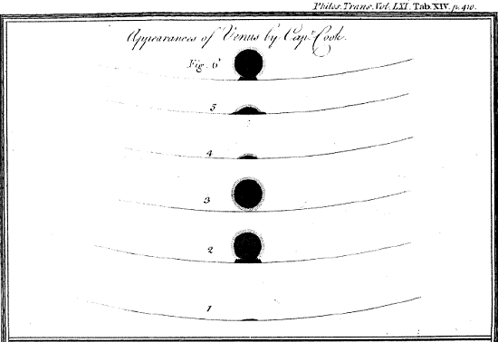
- James Cook visited the Pacific several times on his voyages.
- On his way to Australia in 1769, he stopped on the coast of Tahiti (an island in French Polynesia) to view the Transit of Venus.
- This was when the Venus appeared as a small black disc travelling across the sun. This was very unusual and is only thought to occur every 243 years.
- The Enlightenment, and the desire to find out more about the world, therefore led to voyages for scientific and astronomical purposes.
- The Dutch updated maps of the world to include islands they had discovered in this area and competed with the British to gain influence in this area.

Slavery
Most of the people who became slaves in North America were from West Africa. White traders attacked and captured villagers by setting fire to the huts, or capturing you whilst hunting. Often African tribesmen sold their prisoners of war in exchange for guns. Slaves were marched to the coast in long lines called coffles. Half of the people captured with you died of hunger or sickness, while you were walking to the coast. Slaves were forced onto ships either tight pack or loose pack in the cargo hold. The middle passage was the route to America. The ship was terrible - dirty, and smelly, lasting for two or three months. Slaves wore chains that fastened them to people on either side. Almost one out of ten of the slaves got sick and died. Sometimes people gave up and tried to starve themselves to death, but the sailors beat them or tortured them until they ate something.
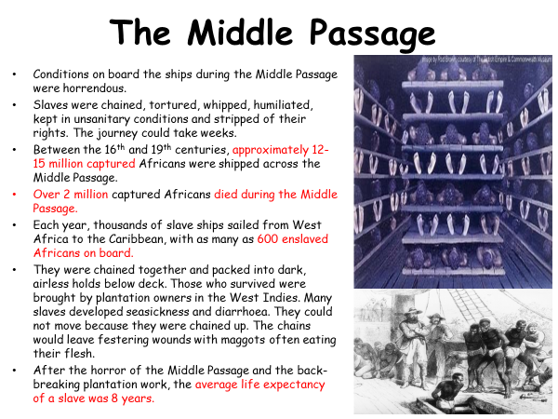
Slave Auction: Selling people to be slaves. The slave trader sold slaves to whoever would pay the most and given a new name. Families were split up. Slaves were prepared using rust to cover whip marks, plugged with tar and given laudanum to calm them down. Most slaves went to southern states like Mississippi on plantations to pick cotton. Conditions were usually horrible, working 14 hour days doing back breaking work. The overseers were cruel and whipped the slaves. Punishments for slaves could include whipping, ear cut off, sold to another plantation and hanging.
Plantation Life:
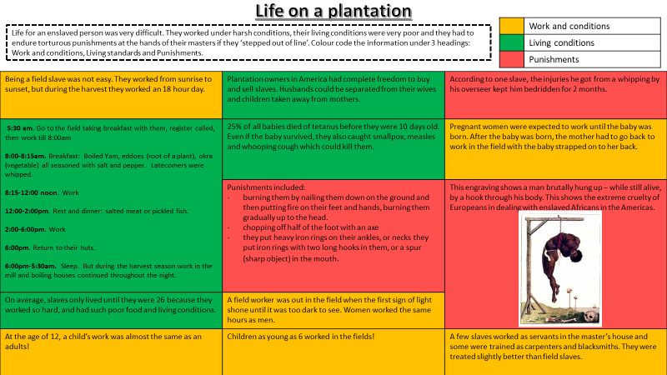
The American Civil War began in April 1861 and was between the North who did not use slavery and the Southern states. The South States broke away from the North and formed the Confederate states of America Abraham Lincoln said that the USA could not be a great country if it was half-slave and half-free. At first slaves from the South ran to the free north to help their army but were sent back. Soon Northern Generals allowed slave runaways to join their Unionist army. In 1863 the Emancipation Proclamation declared all men as free. Remember, the British had already outlawed slavery in 1833 across the Empire.

Industrial Revolution social changes
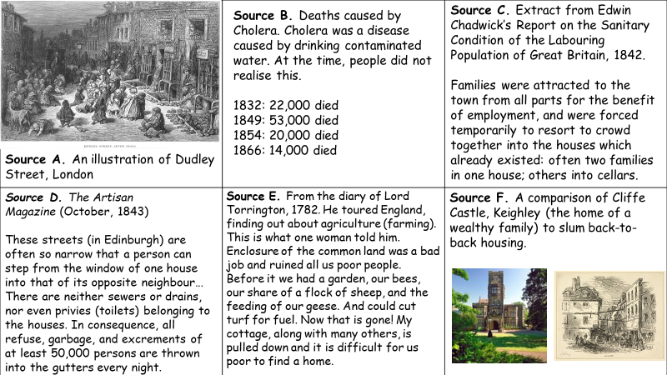

Lloyd George

