Key Vocabulary
Flowol | Flowol is a piece of software that allows you to control a number of different situations using flow diagrams
Algorithm | A set of instructions which is followed to solve a given problem. Can be represented using a flowchart
Flowchart | A diagram that shows an algorithm or process, made up of boxes representing steps, decision, inputs and outputs.
Computational Thinking | The thought process of taking a problem, working out how it can be calculated by a computer, and finding a solution.
Program | A sequence of instructions used by a computer. Sequence The order which the computer will run code in, one line at a time.
Selection | A decision made by a computer, choosing what code should be run only when certain conditions are met.
Condition | Checking to see whether a statement or sum is true or false
Iteration | When a section of code is repeated several times – also known as looping.
Input | Entering data or information into an algorithm.
Output | Displaying data or information as a result of an algorithm
Simulation | A model that produces an output, either visual or physical, as it runs
Flow | How data moves through a program, explained using arrows in a flowchart.
Comparative Operators | Symbols used to compare one value to another (see below table for examples) and return a True/False.
Execute | Means 'running' the instruction or program
Sub-routine | Sequences of instructions that can be called and used when required, this is called sub-routine
Sensor | An object whose purpose is to detect events or changes in its environment, and then provide a corresponding output
Variable | A value where data is stored and can be changed when used in a program.
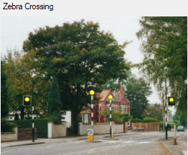
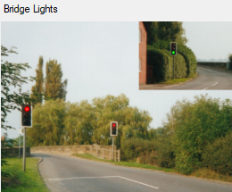
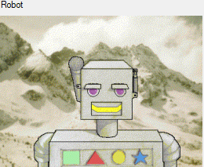
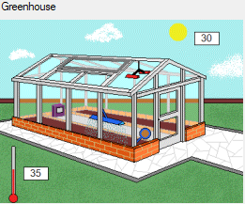
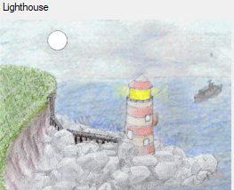

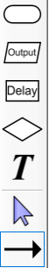
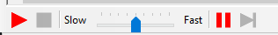
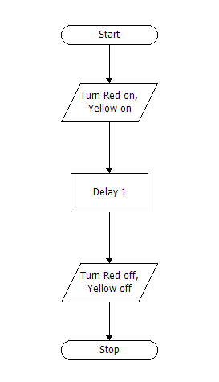
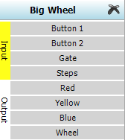
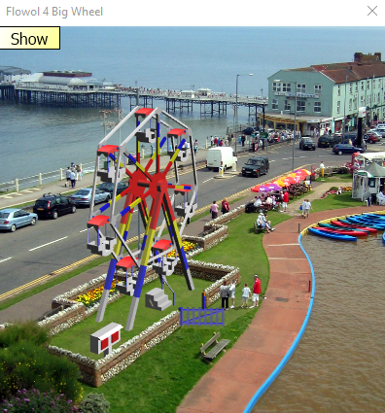
Programming Tools
Run / Stop Adjust Speed
The Workspace
The Status Panel
The Mimic

Start/Stop symbol. This must be used to start the flow diagram, and also to stop it when it’s finished. | 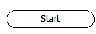 | Output symbol. This controls if the outputs are on. For example, a motor or a light. | 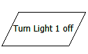 | Process symbol. This allows you to put a delay or a repeat in your flow diagram | 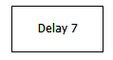
Decision symbol. This lets you add a decision or a condition to your flow diagram | 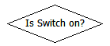 | Label.  This allows you to add text to your diagram | 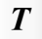 | Edit.  This allows you edit parts of your diagram | 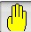
This links all the symbols together and completes the flow diagram. | 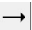 | Play/Stop  This runs/stops the program

