Key Vocabulary
Vector | is the use of polygons to represent images
Bitmap | is the use of pixels to represent images
Coordinates | is the group of numbers used to indicate the position of a point or line
Pixel | is the smallest unit of programmable colour in a bitmap image
Resolution | is the amount of pixels per inch
Scalable | able to be changed in size without losing quality
DPI  dots per inch | a measure of printing resolution
Gradient | is a gradual change from one colour to another
Saturation | is the intensity of colour in a bitmap image
Brightness | is the brightness of light in a bitmap image
Contrast | is the amount of difference between light and dark tones
Layer | images or effects overlaid on top of one another
Font types
Pointer Tool-Select an object
Node - bend lines, change dimensions
Freehand Pencil
Freehand Paintbrush
Pen -to draw curves
Dimensions tool
Paint / erase / knife
Insert shapes
Artistic Text (for titles)
Import image
Colour picker
Paint pot (fill/ gradient)
Transparency tool
Shadow tool
Crop
Envelope (bend shapes)
Blend
Add effects
3d tool (changes to 3d)
Shape Builder Tool

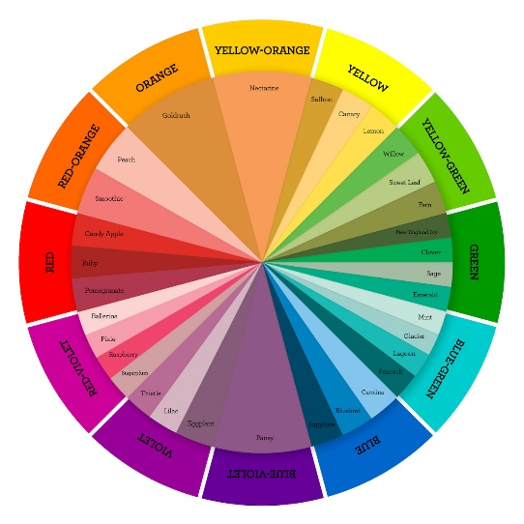
Colour Vocabulary
Primary | Are the 3 main colours. They cannot be made, but are used to make all other colours
Secondary | Are made by mixing 2 primary colours
Tertiary | Are made by mixing a primary and secondary colour together.
Complementary | Are opposite on the colour wheel.
Harmonious | Are next to each other on the colour wheel.

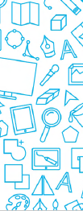
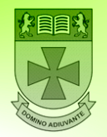
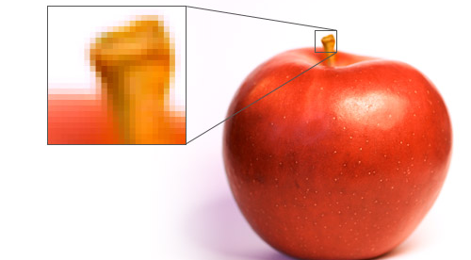
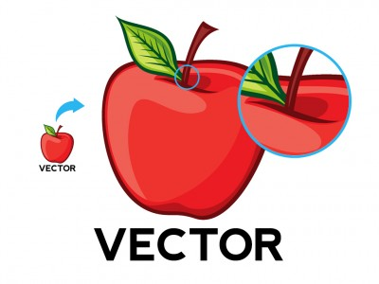
Common Software used for each type
Bitmaps | Adobe Photoshop  Serif Photoplus  Adobe Lightroom  Adobe Fireworks  GIMP  Paint
Vectors | Serif Drawplus  Adobe Illustrator  Adobe Fireworks  Inkscape  Corel Draw  Adobe Flash

Examples of how the school badge can be changed with a selection of tools within Photoplus
Facts about Graphic types
 | Bitmap
They can never be photographs | They are made up of pixels
Not as commonly used | They are always a rectangle shape
The file size is usually smaller | All scanned images are this type
They are cartoon style images | They are measured in dots per inch
When you enlarge them they still look the same | Each pixel can be edited individually
You can edit individual objects | File size is usually larger
Made up of objects and lines | When you enlarge them they lose quality
Fonts are created as this | The most common type of graphic

Top Tips
For very precise object selection draw a lasso around an object to select it.
To resize to any object drag from an object's corner handle. This resizes in two directions. If you drag an object’s side handles, you’ll stretch or squash the object in one direction.
Click the Pointer Tool to select, move, copy, resize, or rotate objects. You can select and rotate an object around a centre of rotation.
Node Tool
Click to use the Node Tool to manipulate the shape of objects, or move or copy objects.
To select all objects on the page press Control + A
To draw a sharp corner or a straight line, press the Alt key.
Quick Shapes are pre-designed objects that you can instantly add to your page, then adjust and morph into a variety of further Quick Shapes.

