Summary
Hyper Text Markup Language (HTML) is a basic programming language for building web pages. It uses a set of predefined tags that the web browser then interprets and renders/displays.
The World Wide Web Consortium (W3C) is responsible for standardising HTML and releasing updated specifications that revise existing tags, introduce new tags and identify deprecated tags and should be the first reference point for any matters concerning HTML.
Common browsers include: Internet Explorer, Firefox, Safari, Opera and Chrome.

Key Vocabulary
Browser | An application used to view web pages, e.g. Internet Explorer or Google Chrome.
Hyper Text Markup Language (HTML) | Hyper Text Markup Language. The language used to write and display web page documents.
Hyperlink | A link in a document or webpage that connects to another location.
Internet | A global network connecting millions of computers.
Web browser | An application that displays web pages.
Web Page | A page designed for, and viewed in, a web browser.
Website | A web page or group of web pages hosted on one web server and viewed in a web browser, usually maintained by a person, group or organisation.
Bold | Formatting technique that makes the font bold
Italic | Formatting technique that makes the font Italic
Underline | Formatting technique that makes the font U
Tag
Using HTML to create websites

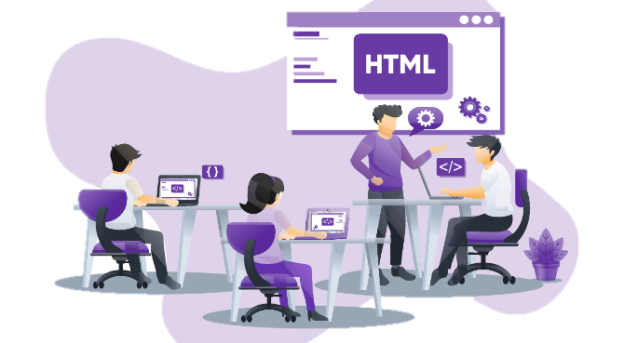
HTML can be written in specialist software, or in a simple text editor like Notepad. As long as the document is saved with the file extension‘.html’ it can be opened and viewed as a webpage from a browser. This example HTML code displays a message on a webpage:
<html>
<body>
<h1>Hello world</h1>
<p>This is my first webpage</p>
</body>
</html>
The code uses tags to describe the appearance of the information:
<html> states that the document is a HTML document
<body> states that the information appears in the body of the page
<h1> states that the following text appears as a prominent heading
<p> states that this is the beginning of a new paragraph

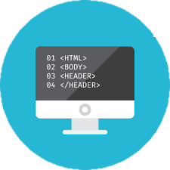
Html Headings

HTML headings are defined with the <h1> to <h6> tags.

<h1> defines the most important heading.

<h6> defines the least important heading.
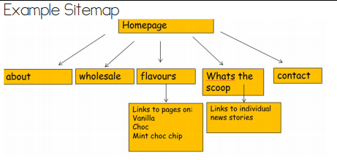
Example
Heading 1
Heading 2
Heading 3
Heading 4
Heading 5
Heading 6

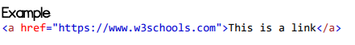
HTML Images
HTML images are defined with the <img>tag.
The source file (src), alternative text (alt), width, and height are provided as attributes
Example
HTML Links
HTML links are defined with the <a>tag.
Example <a href=”https://www.w3schools.com>This is a link <a>
The link's destination is specified in the href attribute. Attributes are used to provide additional information about HTML elements.
Html Explained
- The <html> element is the root element of an HTML page
- The <head> element contains meta information about the document
- The <title> element specifies a title for the document
- The <body> element contains the visible page content
- The <h1> element defines a large heading
- The <p> element defines a paragraph

Working with HTML
HTML is typically written (or generated) in two ways:
Using a plain text editor, e.g. Notepad, Notepad++ or TextPad. Using a What You See Is What You Get (WYSIWYG) editor, e.g. Dreamweaver, iWeb or SeaMonkey.
Plain text editor
An editor like Notepad offers greater control over the code when compared to a WYSIWYG editor because each and every character that forms the HTML and the resulting web page is hand typed. The disadvantage is it’s a slow process.
WYSIWYG editor
The web page is designed, and the content written and styled, using a series of tools. The page can be previewed in the default browser from within the application. This makes building a web page much faster because only a limited knowledge of HTML is needed as it’s automatically generated.
Versions of HTML
Over the years there have been several versions of HTML. Each successive version has more tags, al-lowing the programmer to build more advanced webpages. The latest version, released in 2012, is HTML5.

