Common Formulas/  Functions | =sum | Adds a range of cells together
 | =average | Finds an average for a range of cells
 | =min | Returns the smallest value in a range
 | =max | Returns the highest value in a range
 | =count | Counts cells if they meet that condition
If | One of the logical functions, to return one value if a condition is true, and another value if it is false.  For example IF(C6>50, “too expensive”, “cheap”)
Count If | =countif(where do you want to look?, what do you want to look for?)  For example =countif(C27:C30, “Please”)  If in the range it says please, count it
Auto Sum | Excel automatically enters a formula (That uses the Sum function) to sum the numbers  Key stroke shortcuts  (An alternative to the right mouse button):  Ctrl + X – Cut selected data  Ctrl + C – Copy the selected data  Ctrl + V – Paste copied/cut data  Ctrl + A – Select all (entire workbook)  Ctrl + S – Save  Shift + arrow key – selects a single cell at a time in the direction of the arrow key pressed
Golden Rule – Every formula starts with an =
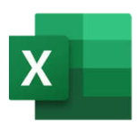
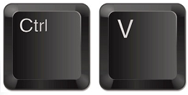
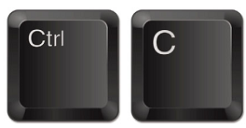
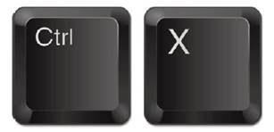
Microsoft Excel is a software program that allows users to organise, format and calculate data with formulas using a spreadsheet system.
Operators
+ | Adds together numbers / cells
- | Subtracts once cell or number from another
* | Multiplies two numbers / cells
/ | Divides once cell or number from another
> | Greater than
< | Less than
>= | Greater than or equal to
<= | Less than or equal to

A range is a selection of cells.
For example (A1:C3)
 | A | B | C | D | E
1
2
3

Cell references begin with a letter and finish with a number.
For example C3.
 | A | B | C | D | E
1
2
3

Spreadsheet an electronic document in which data is arranged in the rows and columns of a grid and can be used in calculations. | Column Heading is the grey coloured row containing the letters (A, B, C, etc.) used to identify each column in the worksheet. | Cell a box in which you can enter a single piece of data | Cell Reference is the name given to a cell to uniquely identify it. E.g. E4 | Absolute Cell Reference A cell reference that does not change when the cell is moved, copied or filled
Autofill/Fill Handle a software function that automatically enters data in spreadsheets | Data Validation restrict data entry to certain cells, it displays an error message when a user enters invalid data. | Formula an expression which calculates the value of a cell | Function a predefined formula that performs calculations using specific values in a particular order. | Formatting To change the appearance, layout or organisation of a spreadsheet
Graphs/Charts a visual representation of data from a worksheet that can bring more understanding to the data than just looking at the numbers. | Conditional Formatting a feature of Excel which allows you to apply a format to a cell or a range of cells based on certain criteria. | Sort the arrangement of data into a specific sequence. E.g. A-Z, smallest to highest | Filter to allow only certain data to be displayed. | Data types a particular kind of data item, as defined by the values it can take, e.g. Numbers, text, date
Ascending arranged in a series that begins with the least or smallest and ends with the greatest or largest | Descending arranged in a series that begins with the greatest or largest and ends with the least or smallest | Borders form an edge along or beside (something) | Columns a vertical series of cells in a chart, table, or spreadsheet. | Worksheet a collection of cells organized in rows and columns
Rows the range of cells that go across (horizontal) the spreadsheet/ worksheet. | VLookUp ‘Vertical Lookup'. It is a function that makes Excel search for a certain value in a column (the so called 'table array'), in order to return a value from a different column in the same row. | Profit a financial gain, especially the difference between the amount earned and the amount spent in buying, operating, or producing something. | IF statement The Excel IF Statement tests a given condition and returns one value for a TRUE result and another value for a FALSE result. | Macro an action or a set of actions that you can run as many times as you want. When you create a macro, you are recording your mouse clicks and keystrokes.
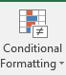
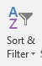
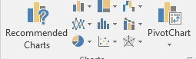
Autofill
Click on the cell you want to duplicate, grab the black cross in the bottom right-hand corner and drag it down to the remaining cells.
Conditional Formatting
Click on this button to add conditional formatting
Then click on highlight cell rules, depending on what your rule is select the next option that matches the rule you want to create
Why do we use Spreadsheets? Spreadsheets are used to store information and data.
Once we have our information in a spreadsheet we can run powerful calculations, make graphs and charts and analyse patterns.
Uses of spreadsheets:
- Modelling and planning
- Wages / invoice
- Budget tracker
- Stock tracking of a business
- Money use in a business
- Teacher may use it to keep a record of student’s grades.
Cell reference
A cell reference is the name given to a cell to uniquely identify it. E.g. E4. An absolute cell reference ensures that 1 cell always remains constant even when autofill is used. E.g. $E$4
Graphs
Click on the insert tab at the top of Excel
Pick the chart that you need:
Formulas
Only use when creating a calculation between 2 cells. E.g.
= A1 + B1 (adds)
= A1 - B1 (subtracts)
= A1 * B1 (multiplies)
= A1 / B1 (divides)
Sort & Filter
Sorting data organises it in a
specific way e.g. alphabetically
filtering data makes it easy for us
to find one specific piece of data without having to look through every piece of data

