Year 7 End of Year Geography Revision
Cycle 1: Population and Migration

Key Points
- Population is influenced by birth ratesand death rates.
- Population changes can be shown on a Demographic Transition Model (DTM).
- There are different ways of managing population such as encouraging people to have more or fewer children or limiting birth rates by law.

Changes in population
The population of a country changes over time. These changes are caused by three factors - births, deaths and migration. The change in population caused by births and deaths is called natural change. The population will get larger or smaller depending on birth rates and death rates. If the birth rate is higher than the death rate there will be a natural increase. If the death rate is higher than the birth rate there will be a natural decrease.
Population is also affected by migration. Migration includes both immigration, when people move to a country, and emigration, when people move away from a country.

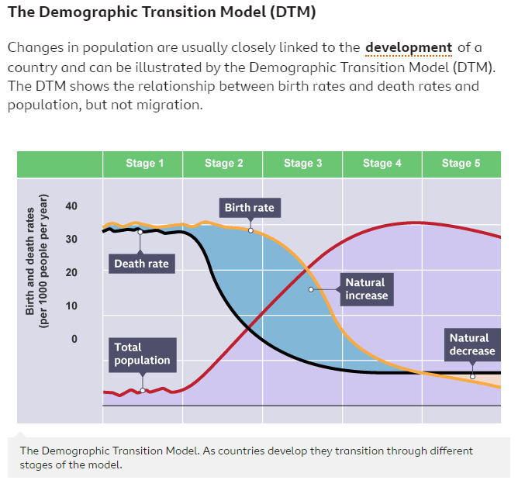
The DTM can be split into five stages:
Stage one – Population is low but there are high birth and death rates.
Stage two – Population begins to increase as death rates fall due to improvements in medicine and sanitation. Birth rates remain high.
Stage three – Population is still increasing but more slowly now as birth rates fall due to increased access to contraception and family planning, improvements in health education and a general desire for smaller families. Death rate continues to fall but at a slower rate than at stage two.
Stage four – Population is now high but as birth rates and death rates are now low, the rate of population change is steadier than before.
Stage five – Population may start to decline at this point due to low birth rates and an ageing population leading to a slight increase in death rates.

Population pyramids
When looking at population, structure as well as total numbers is important. This means looking at the number of people in each age group and how those numbers are changing. These are known as population pyramids. Countries at different stages of the DTM have different shaped population pyramids.
The interpretation of a population pyramid can help a geographer understand the structure of a country, for example:
- a wide base to the pyramid indicates a young population
- wider bars at the top of the pyramid indicate an ageing population
There may be anomalies in the pyramid, for example:
- a longer than expected bar may indicate a large amount of immigration at that age range
- a shorter than expected bar may be due to war or famine
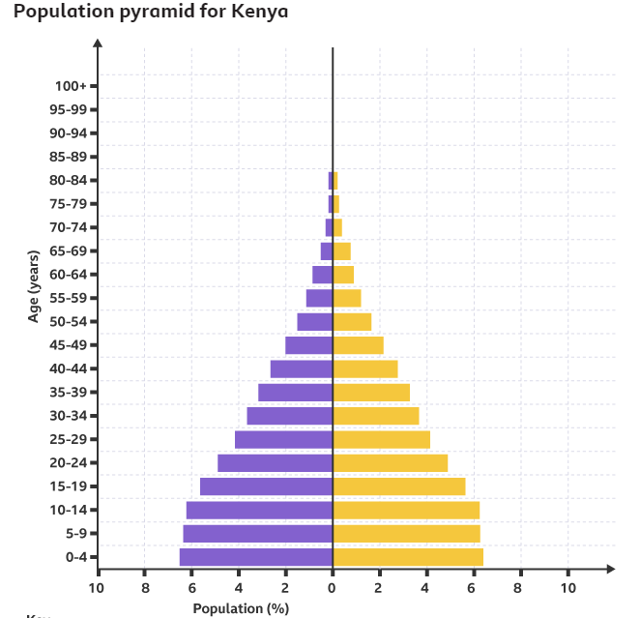
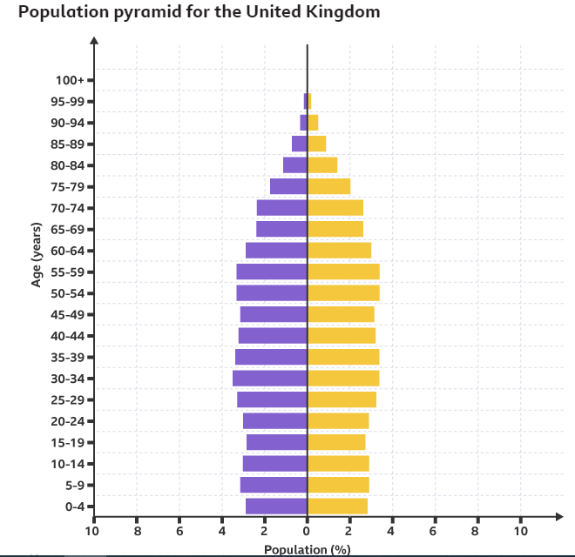

How do countries manage their population?
Governments sometimes create policies to manage their population. They may try to increase birth rates, and therefore the population, by encouraging people to have children through pro-natal policies. Alternatively, they may try to decrease the birth rate, and slow the rate of population growth, by discouraging people from having children through anti-natal policies.

United Kingdom
Pro-natal strategies are used in the United Kingdom to try and boost fertility rates. These include incentives such as child benefit payments, free childcare, and improved maternity and paternity leave. There are also family-friendly employment laws such as the right to request flexible hours and job sharing.

Pro-natal policies are policies designed to increase the birth rate.

China
In the 1970s, China attempted to reduce the country's birth rate and slow the population growth by introducing the one-child policy whereby families could only have one child. The policy did slow population growth but also had some negative impacts. The policy led to a decrease in human rights because people were not allowed to make decisions about the size of their families. China now has an ageing population which threatens to slow economic growth as the number of working-age people decreases. China has made some changes to their policy and, as of 2021, families are now allowed to have three children.

Kerala, India
The state of Kerala in India also faced high population growth. This was creating many problems, such as overcrowding and a shortage of food. The government have now slowed this population growth through a mixture of contraception use and the introduction of government policies to improve education and healthcare, especially for women. Improvements in education have also led to infant mortality rates falling. This has meant that Kerala has managed to control its population growth without restrictions on family size.

In Kerala 85 per cent of women can read and write. Improvements in education have led to infant mortality rates falling.

Key points
- There are different reasons why people migrate, such as for work opportunities or to seek safety.
- Migration is influenced by push and pull factors.
- Migration of people can happen both between different countries, and within the same country.
- Migration can have a number of effects on both the host and source countries.
Why do people migrate?
- Migration is the movement of people from one area to another. This may be temporary or permanent and may be international or within a country.
- The decision to migrate is often a difficult one and one taken out of dire need, for safety, or for the hope of a better life. The reasons why people choose to leave one area and go to another are known as push and pull factors. Push factors are things which make people want to leave and pull factors are things attracting them to the new location. Often the decision to move from one area to another is based on a mix of both push and pull factors.

- Push and pull factors which can cause migration

Push factors
- A person may choose to leave their area or country voluntarily, or they may be forced to leave. For example, refugees and asylum seekers may be forced to leave to escape a war or conflict.
- People may also have to leave a country as a result of a natural disaster. In the aftermath of the May 2021 Mount Nyiragongo volcanic eruption in the Democratic Republic of the Congo (DRC) for instance, around 400,000 people were forced to flee the Congolese city of Goma. Thousands of those people entered neighbouring Rwanda, where they stayed in the border city of Gisenyi.

Pull factors
People may choose to voluntarily leave their area or country to improve their standard of living. These people are known as economic migrants. They may move from a low-income country to a high-income country or from a rural to an urban area in the same country in the hope of finding a better paid job. Although this is classed as voluntary migration, some people may feel forced to move to support their families.

The effects of migration
Migration can have consequences for both the host and the source countries and these can be both positive and negative.

Positive impacts of migration for source country | Negative impacts of migration for source country
Reduction in unemployment. | As the population decreases, so too does the amount of money received from taxation.
Less demand for services such as healthcare in the country due to the now lower population. | Those who leave are often those who are highly skilled and educated, leaving fewer skilled workers in the source country. This is known as ‘brain drain’.
Money sent back home from the host country can help boost the source country’s economy.

Migration can enrich a country by bringing new cultures and cuisines. Chinatown in London has been at its present site in the West End since the 1950s.
Positive impacts of migration for host country | Negative impacts of migration for host country
Skilled workers arriving in the host country means shortages can be filled without having to invest in training people to fill these roles. | Large numbers of people coming to a country all at once may lead to environmental impacts as the migrants compete for resources. An increase in migrants to one place can increase the levels of pollution in that area.
More money is paid to the government in taxes and more money is spent in businesses, providing a boost to the economy. | Increased competition for jobs may lead to a rise in resentment and potentially conflict between migrant workers and locals.
Attracting younger workers is a way of coping with an increasingly ageing population.
An exchange and appreciation of cultures and a multicultural society.

Cycle 2: Coastal Landscapes
The landscape of a coastal region is formed as a result of various processes:
- Rocks are eroded.
- Then, the sediment that comes off is transported.
- Finally, the sediment is deposited elsewhere.

1. Erosion
Erosion is when the rocks are worn away, in this case by the action of waves. There are several different processes of erosion:
Hydraulic action/power | When waves crash against a cliff, they force air into cracks in the rock. The force of this trapped air causes the rock to weaken and eventually break.
Abrasion/corrasion | This is where sediment being carried by the water wears away the surface, almost like sandpaper.
Solution | Chemicals in the water dissolve certain types of rock such as limestone. However, there is some debate about how much coastal erosion this causes.
Attrition | Rocks crashing into each other result in them becoming smoother and more rounded.

2. Transportation
Sediment in the water will be transported. This happens in four different ways:
- suspension - lighter material floats within the water
- traction - larger rocks roll along the sea bed
- solution - some material, such as chalk, gets dissolved into the water
- saltation - smaller rocks, if they are too heavy to be suspended, hop along the sea bed

Different ways sediment can be transported in the sea

3. Deposition
When waves carrying sediment reach the shore, they will deposit it in areas where they lose energy - often in sheltered areas such as bays. This can lead to the formation of beaches. Sometimes the waves will continue to move sediment along the beach. The direction this is moved in will depend on the prevailing wind. If the wind is coming in at an angle, then the waves will also move up and down the beach at an angle. This causes the sediment to be moved in a zig-zag pattern. This is called longshore drift.

Coastal landforms

Geology
The geology of a coastline influences the landforms we see there. Some rocks are harder than others and so are more resistant to erosion. For example, rocks such as granite are hard and erode much more slowly than softer rocks, such as boulder clay or shale.

https://www.bbc.co.uk/bitesize/topics/z6bd7ty/articles/z6394xs - use this link to look at different coastal landforms in more detail

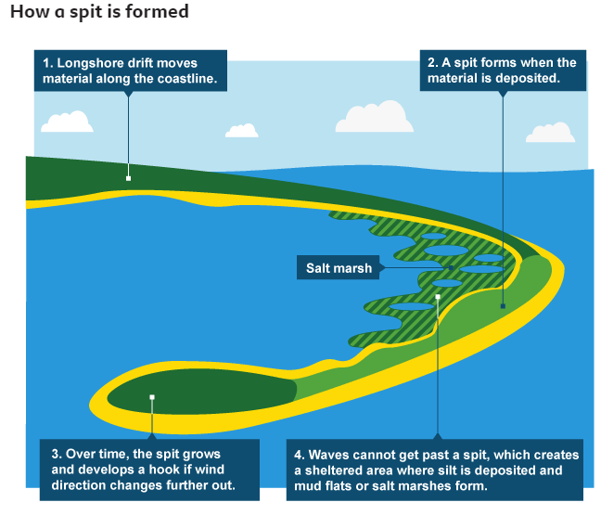
Coastlines need to be managed to prevent natural processes, such as erosion and flooding, destroying vulnerable areas of the coast. Often the coastline is used by people for homes, agriculture, industry, tourism or other businesses. In addition, there are many coastal areas which are sites of natural beauty or are of special scientific interest. A failure to prevent erosion and flooding can lead to a loss of life or property.

Erosion is the wearing away of the land by natural forces such as the sea
With climate change leading to rising sea levels and more extreme weather, the coastline may become increasingly vulnerable.

Deciding which coastlines to protect
Before taking any decision to protect a section of coast, local authorities will undertake a cost-benefit analysis. If the cost of protecting the land outweighs the benefit, then the land may be left for nature to take its course.
One coastline in the UK that suffers from erosion is the Holderness Coast in Yorkshire. The soft rock of the coastline is the fastest eroding coastline in Europe with some areas suffering from ten metres of erosion a year. Some parts of the Holderness coastline, such as the coastal towns Bridlington and Withernsea, are being protected from coastal erosion. Other sections have been designated as 'do nothing' areas and so they have no sea defences at all.

How are coastlines managed?
There are different options available for managing coastlines:
- hard engineering, where man-made structures such as groynes are built to stop longshore drift
- soft engineering, where more natural processes are used, such as regenerating sand dunes

Using hard engineering
- Hard engineering strategies involve building man-made structures to defend the coast. Here are some examples:
- Sea walls
- Sea walls are concrete barriers built along the seafront that deflect waves back to sea. They also protect the land behind them from flooding.
- Advantages - Very hardwearing, protect against erosion and flooding.
- Disadvantages - Usually the most expensive option, they can sometimes be eroded themselves and so need maintenance.

- Rock armour
- Large rocks or boulders can be placed in front of a cliff to absorb the energy of the waves and slow the rate of erosion.
- Advantages - A fairly cheap defence, the rocks look more natural than a concrete wall.
- Disadvantages - Strong waves can cause the boulders to move meaning they need to be replaced.

- Groynes
- Wooden or rock barriers built at right angles to the beach. These trap sediment to build up a larger beach, which absorbs wave energy and reduces erosion. This has been successful in protecting the town of Mappleton on the Holderness Coast. However, the groynes have prevented sediment from moving southwards along the coastline, which has led to an increase in erosion elsewhere.
- Advantages - Builds up a large beach which, as well as providing protection from erosion, can attract tourists.
- Disadvantages - As groynes stop the movement of sediment they can cause sediment starvation further down the coast, leading to further erosion there.

- Gabions
- Gabions are cages of rocks. These provide a barrier between the sea and the land, reducing erosion and providing stability to the shoreline.
- Advantages - Cheap and easy to build.
- Disadvantages - Some people find gabions ugly as they don’t look as natural as other defences, especially as the wire cage starts to rust.

- Using soft engineering
- Soft engineering options use natural processes to protect the coast. Here are some examples:
- Beach nourishment
- Sand or shingle is placed on a beach to create a higher and wider beach. This will absorb more wave energy and protect the land behind.
- Advantages - The beach looks natural and it can help to attract more tourists.
- Disadvantages - The new sand and shingle wash away and so the process needs to be repeated over time.

- Dune regeneration
- Sand dunes provide natural protection against storms and flooding. By planting marram grass in the area, sand is trapped and large dunes form, providing a barrier between the sea and the land.
- Advantages - Sand dunes provide natural protection from the sea. It is relatively cheap to carry out planting projects.
- Disadvantages - There is no guarantee that the sand dunes will stay in place. They may be damaged by storms or by people walking over them.

- Managed retreat
- Some areas of low-value land are allowed to flood creating a salt marsh. This area of land acts as a buffer.
- Advantages - Salt marshes provide natural protection from the sea and they are an important habitat for wildlife.
- Disadvantages - Land is sometimes lost to the sea and so compensation has to be paid to the landowners.

Cycle 3: Ecosystems

What is a biome?
Biomes are large scale ecosystems. They are defined by factors such as climate, soils and vegetation. The world's major biomes include rainforest, desert, savanna grassland and tundra.
Ecosystems are communities of plants and animals that live in a particular environment. They range from small ecosystems such as a freshwater pond, to global ecosystems such as deserts. They contain biotic and abiotic components.
Biotic means living things like insects, plants, trees and mammals.
Abiotic means non-living things such as soils, rocks and the climate.

Some of the world’s major biomes
- Tropical forests are found near the equator in Central and South America, parts of Africa and Asia. They are hot and humid and contain a huge variety of plants and animals - around half of all the world's species. The trees are mostly hardwood. The climate is called equatorial.
- Savanna or tropical grasslands are hot and dry, dominated by grass, scrub and occasional trees. They have two distinct seasons - a dry season when much of the vegetation dies back, and a rainy season when it grows rapidly. They are found in central Africa (Kenya, Zambia, Tanzania), northern Australia and central South America (Venezuela and Brazil).
- Desert is the driest and hottest of areas. The world's largest desert is the Sahara in North Africa. Areas of scrub land that border the desert are called desert scrub.
- Temperate deciduous forests contain trees that lose their leaves and are found across Europe and USA. The weather is mild and wet. The climate is called temperate maritime.
- Coniferous forests, containing evergreen trees, are found in Scandinavia, Russia and Canada. They have a cool climate with moderate rainfall called cool temperate.
- Tundra/Polar surrounds the north and south poles. They have an extremely cold climate, with limited numbers of plants and animals able to survive there.
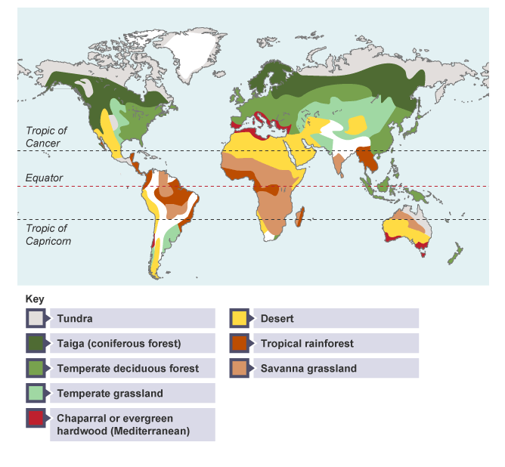

Biome climates
Climate is the average weather conditions over a longer period and over large areas.
The temperature and the amount of rainfall an area receives depend on:
- position in relation to the poles and equator
- the effect of any nearby large water bodies such as seas and oceans
- the way that the landscape changes in height, which is called relief
Climate graphs show the average annual rainfall and temperature throughout the year for a particular area. They can give us a better understanding of the type of climate experienced in a biome.

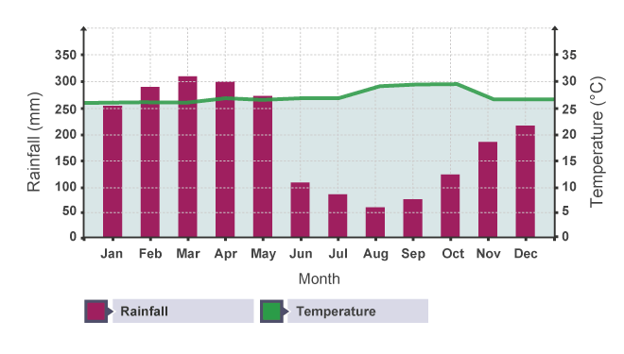
This graph shows temperature and rainfall typical of a tropical rainforest. There is a distinct rainy season from December to May. The amount of rainfall varies over the year - with the highest monthly rainfall in March with over 300mm, while the lowest is in August with less than 50mm. Over the year, the temperature only varies by 2°C.
Other biomes would also have distinct climate graphs. The desert biome would receive very little rainfall across the year with average temperatures being high throughout. A deciduous forest would have a milder temperature and a consistent amount of rainfall all year round.

Adapting to different habitats
In order to survive in each biome, plants and animals have had to adapt to cope with the environment they live in and the challenges they might face.
Here are two examples of how animals have adapted to their habitat.

Adapting to hot climates
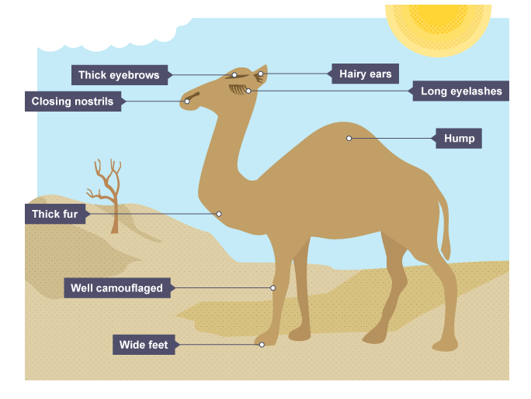
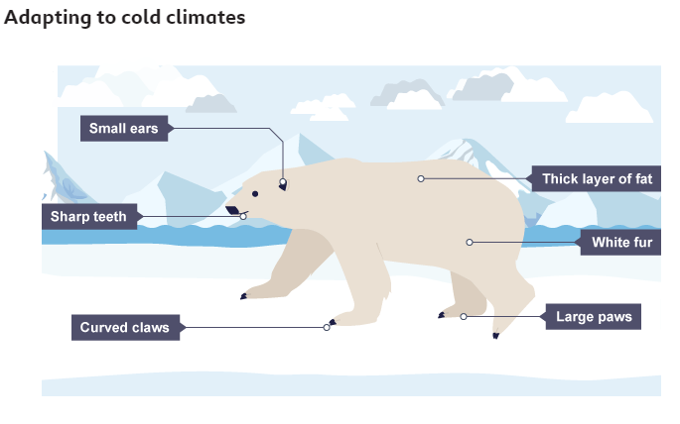

Human impact on biomes

Deforestation
Deforestation is the clearing of large areas of trees. It is a particular threat to tropical rainforests in places such as the Amazon Basin.
Increased human activity has led to large portions of the forests across the world being lost. This is mainly as a result of:
- logging - trees like mahogany are cut down and sold for timber to make furniture. Other trees are cut down for making paper products
- farming - large areas of the rainforest are lost as spaces are cleared for cattle ranches that produce beef
- mining - the Amazon Basin is rich in natural resources such as iron ore, copper, tin, aluminium, manganese and gold. The rainforest is cleared to get access to these resources
As a result of these activities, animals are being driven out of the forests or even made extinct.
The orangutan is a prime example of a threatened species. A century ago, they lived in forests all across south-east Asia but today they’re only found on the islands of Sumatra and Borneo.
The rainforests where they live are being cut down to make way for agriculture and the growing of trees for palm oil production.

Climate change
Human-caused climate change has a drastic impact on the world's biomes.
In arid and semi-arid biomes, desertification is becoming even more common. This is a reduction in the productivity of the land temporarily or permanently. It can’t support the same plant growth it could in the past.
Desertification can be caused by several things such as:
- drought
- deforestation
- overgrazing
- fire
- overfarming
When the land is less productive it is harder to farm and can result in economic challenges.

Dried cracked mud seen at the Valdeinfierno in Zarcilla de Ramos, Spain

A clearing of chopped trees in a rainforest

Climate change is having a profound effect in Greenland with glaciers and the Greenland ice cap retreating
Polar biomes are affected by the rise in global temperatures. The ice caps at the poles are melting at an increasing rate.
It is becoming more difficult for animals, such as polar bears and walruses, because they are losing their native habitats. These animals have been forced to migrate further south in search of land and food to sustain themselves.
In the Antarctic, disappearing sea-ice threatens to wipe out the penguin species that live there.

Tropical Rainforests
- Tropical rainforests lie along the equator, mainly between the Tropics of Cancer and Capricorn.
- Rainforests have four main layers: the emergent, the canopy, the under canopy and the forest floor.
- There are many causes of rainforest deforestation, which leads to loss of habitats, soil erosion, flooding and global warming.
- International agreements, 'debt for nature' swaps and selective logging and replanting of trees can all be used to help reduce deforestation.

The layers of a rainforest
Rainforests have four main layers: the emergent, the canopy, the under canopy and the forest floor. The top emergent layer of the rainforest receives the most sunlight, while the forest floor at the bottom receives the least amount of sunlight. Each layer experiences different levels of water, sunlight, and air circulation.
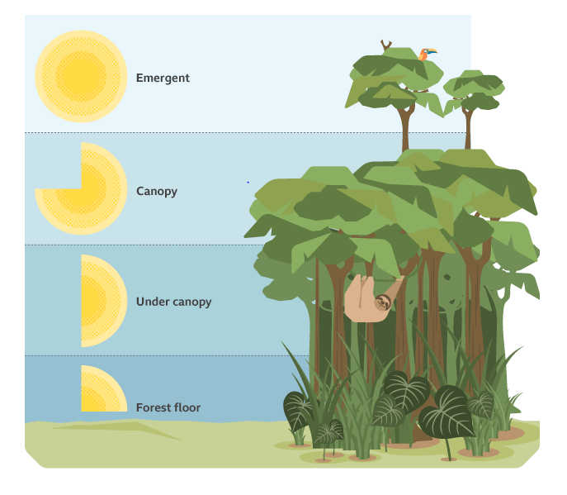
Emergent | The tallest trees in the forest, some over 50 m in height. Parrots and bats live here. Parrots have sharp beaks to crack open nuts and large toes to grip the tall trees, which sway in the wind.
Canopy | The canopy receives high levels of solar energy. Monkeys and sloths live here. Monkeys have strong tails to help them to swing through the trees.
Under canopy | A lower level of trees that only receives around 2 to 15 per cent of the sunlight falling on the forest. Frogs and snakes thrive in the damp conditions here. The flying frog has web-like feet, which allow it to glide through the air.
Forest floor | The forest floor is very dark and often covered in fallen leaves. Jaguars and gorillas are found in some rainforests. Jaguars have camouflaged fur, which allows them to blend into the forest. They are also excellent swimmers.

What are the causes and effects of rainforest deforestation?
An estimated 12 million hectares of rainforest has been lost annually since 2010. This is an area approximately the size of England each year.
Causes of deforestation include:
- logging for timber and pulp
- large-scale farming
- subsistence farming
- mining
- hydroelectric power (HEP)
- settlements and road building
Deforestation leads to a loss of habitat for people of the rainforest and many animals. Loss of tree cover exposes soil. Heavy rainfall can then cause soil erosion and flooding. On a global scale, loss of rainforests contributes to global warming. This is because trees store carbon.
Rainforests can be managed to prevent deforestation. The table below summarises some ways that this can be achieved.
Type of management | Explanation
International agreements and debt for nature swaps | These are agreements between different countries. For example, the Paris Agreement on climate change (2015) aims to protect the world’s forests. This happens when a country’s debt is reduced in exchange for rainforest conservation (protecting the forests from harm). There are renewed calls for countries like China to swap ‘debt for nature’ with nations that owe them money, such as Laos and Cambodia.
Selective logging | This means only removing the trees that are worth the most money. Selective logging protects the rest of the forest.
Replanting | Replanting areas of lost forest can help repair the damage already done.

