Revision - What happened after William conquered England?

The Harrying of the North in response to rebellion

Some English people rebelled against William including Hereward the Wake in East Anglia and Eadric the Wild in Shropshire.
The biggest rebellion was in the north of England in 1069. It was led by Edgar the Atheling who, as the only son of Edward the Exiled, had a blood-claim to the throne. He was joined by Danish and Scottish armies.
William defeated the rebellion but he still didn't trust the English people. In the north-east of England, from 1069 to 1070, he ordered villages to be destroyed and people to be killed. Herds of animals and crops were burnt. Most people who survived starved to death; there were even stories of people turning to cannibalism. William did not care if they had rebelled or not.
Not only was the population reduced by 75% but land was salted (poisoned) to prevent people growing crops in the future. This is called the Harrying of the North.
Even by the standards of the time, the Harrying was seen as excessively cruel. A Norman chronicler, Vitalis, writing fifty years later said God would punish William for his brutal slaughter, but William had achieved his main aim. He was in control of the North, and he had prevented a future rebellion. Now William was able to place loyal nobles in charge to look after his lands. William could then set about keeping control of his new conquest.

How did William take long term control of England?
William used the methods of control that he was most familiar with: castles and the feudal system. But he also adopted a new method in the form of the Domesday Book.
- Castles: William had new, loyal nobles from Normandy build over 100 castles all over the country. They were built extremely quickly, some in just eight days! From their castles, the new Norman lords could control the local area, and the sight of them made it clear who was now in control. The need for quick constructions meant materials such as earth and wood were used and although this sped up the building process, it meant they didn’t last very long. Over time, the more important ones were rebuilt from stone.
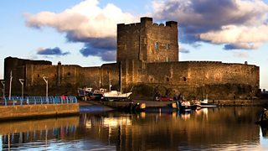
Carrickfergus Castle in Northern Ireland, originally built in Norman times
- The feudal system: William could not be everywhere at the same time. To solve this, he lent parcels of his new lands to nobles, or barons, as they were called at the time. In return for loyalty and taxes, they could use the land. The barons then loaned the land to knights who in turn loaned it to peasants who then did all of the hard farming work! If the barons betrayed William, they would lose their land, and the wealth that came with it.
- The Domesday Book: the book was the end result of a survey of all of England by William to assess the value of the country. It took his two sets of officials a year to complete. The first group asked questions of the people. The questions concerned the value of farms and animals which created England’s wealth at the time. The second group checked the first group’s answers to see if they had told the truth. The book is still in existence today.
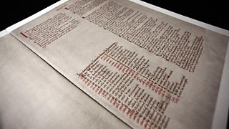
The Domesday Book

How The Norman Conquest changed England and Western Europe
The Norman Conquest changed the face of England and Western Europe forever:
- The Norman Conquest broke England's links with Denmark and Norway, and connected the country to Normandy and Europe.
- William got rid of all the Saxon nobles and imposed the feudal system on England.
- The new Norman landowners built castles to defend themselves against the Saxons they had conquered. This gave them great power, and enabled some of them to rebel against William in the late 1070s.
- William reorganised the church in England. He brought men from France to be bishops and abbots. Great cathedrals and huge monasteries were built.
- The status of women in the Anglo-Saxon period had been relatively high, with the opportunity for rights in land ownership, for instance. The Feudal system introduced by the Normans reversed these changes.
- Norman-French and Anglo-Saxon words make up the English language we use today. For example, royal, law and pork come from Norman-French words, but king, rules and pig come from Saxon ones.
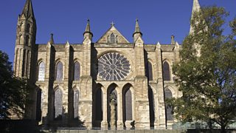
Durham Cathedral, originally built in Norman times
Tensions between the English and their new French rulers lasted for at least three centuries.

Feudal System
Feudal System
Castles
Harrying of the North
Other
Doomsday book
The impact of the Norman Conquest

