Year 7 revision
Identify at least 1 of each of the following methods in the following paragraph.
- Adjective
- Adverb
- Noun
- Verb
- Sensory language
- Simile
- Metaphor
- Simple sentence
- Complex sentence
- Compound sentence
In a hole in the ground there lived a hobbit. Not a nasty, dirty, wet hole, filled with the ends of worms and an oozy smell, nor yet a dry, bare, sandy hole with nothing in it to sit down on or to eat: it was a hobbit-hole, and that means comfort.
It had a perfectly round door like a porthole, painted green, with a shiny yellow brass knob in the exact middle. The door opened on to a tube-shaped hall like a tunnel: a very comfortable tunnel without smoke, with panelled walls, and floors tiled and carpeted, provided with polished chairs, and lots and lots of pegs for hats and coats - the hobbit was fond of visitors. The tunnel wound on and on, going fairly but not quite straight into the side of the hill - The Hill, as all the people for many miles round called it - and many little round doors opened out of it, first on one side and then on another. No going upstairs for the hobbit: bedrooms, bathrooms, cellars, pantries (lots of these), wardrobes (he had whole rooms devoted to clothes), kitchens, dining-rooms, all were on the same floor, and indeed on the same passage. The best rooms were all on the left-hand side (going in), for these were the only ones to have windows, deep-set round windows looking over his garden and meadows beyond, sloping down to the river.

Rewrite the following sentences, in at least two different ways, so that they grab the reader’s attention. The first one has been done for you.
The boy opened the door to the shop.
Trembling with excitement, the boy quickly pulled opened the door to the sweet shop. Holding his breath in anticipation, the boy flung open the door to the sweet shop.
- The ship was sailing across the sea.
- She thought she heard footsteps so she looked behind her.
- It was raining.
- The car was headed for the girl.
- The dog sat frightened in the vets.

Improve the following description to include similes, metaphors, all three sentence types, a variety of punctuation and considered vocabulary choice.
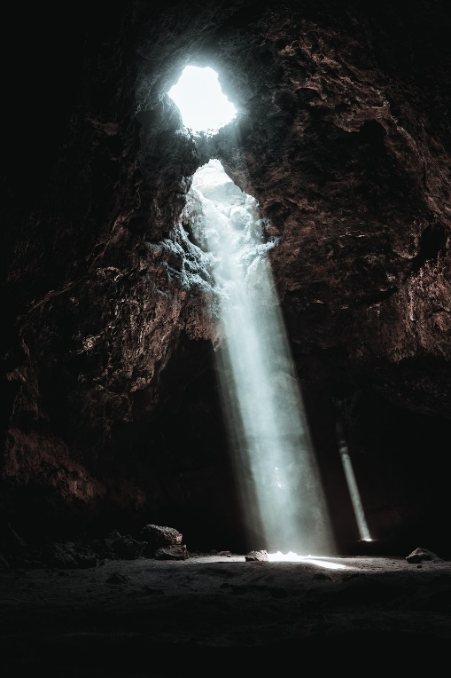
The cave smelt dirty. The water was blue and there was sun coming down. It was a bit scary.

