Year 8 End of Year Geography Revision
Cycle 1: Global Governance

Key points
- Transport and communications allow the flow of goods, labour and capital between countries.
- Transnational corporations (TNCs) are companies that take advantage of global flows to operate in more than one country.
- Globalisation has had a range of impacts.

Globalisation
Globalisation is the process by which countries and people are becoming more connected. Improvements in transport and communications enable people, goods, capital and information to move between countries.
As a result of globalisation, some corporations, or large companies, now operate in more than one country. These corporations are called TNCs (transnational corporations).

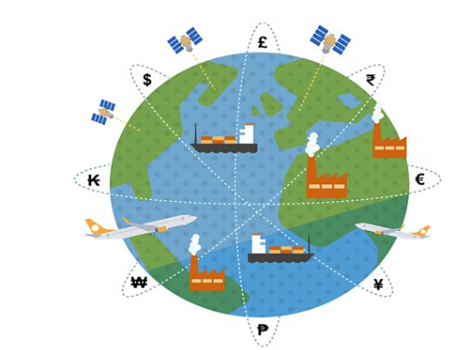

Cycle 2: The water cycle, rivers and glaciation
Cycle 3: The Geography of Conflict

Transnational corporations
TNCs have traditionally had their headquarters in the Triad which is made up of the HICs (high income countries) in Europe as well as the United States and Japan. Companies in the Triad have had an advantage as many of these countries were once colonial powers. Colonial powers grew richer through exploiting the resources of their colonies. This wealth has enabled large companies to grow.

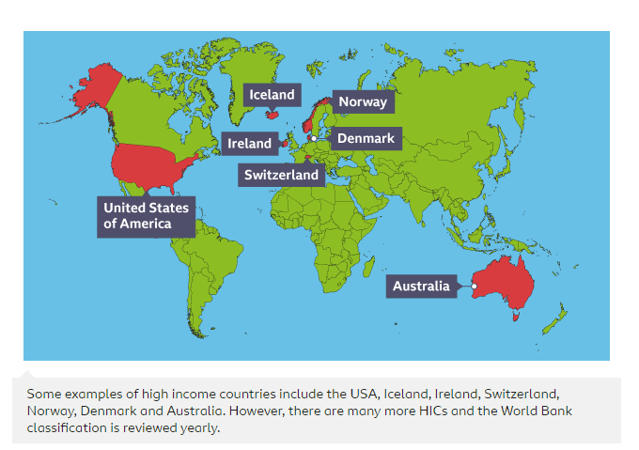
More recently, some MIC countries, such as China, have grown wealthier over time. These countries have become known as NEEs (newly emerging economies). This has led to larger companies and TNCs developing in these countries too.
TNCs often manufacture products in LICs or MICs where wages are lower. This allows them to make more profit from the products that they sell, but it can mean that workers in LICs are exploited.
The relocation of factories has led to industrialisation in many LICs and MICs and deindustrialisation in many HICs.

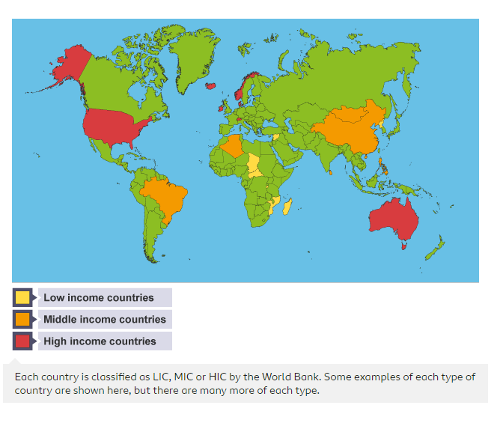

Impacts of globalisation
Globalisation has had both positive and negative impacts. Remember: not all the impacts listed here are equal. Some may be more serious than others.

Employment and resources
- Job opportunities have led to economic growth in LICs and NEEs.
- Deindustrialisation in HICs has led to job losses.
- There is improved access to resources as countries trade with one another.
- Some resources have been overexploited, which means they may run out.

Goods are transported between different countries

Relationships and trade
- Countries rely on one another and are more likely to work together.
- Manufacturing and transportation processes can lead to higher levels of pollution.
- Ideas and skills are shared between countries. This can lead to greater progress.
- Unequal flows of people or capital can lead to some countries having less power. In some cases, TNCs are more powerful than the countries they operate in.

What are the causes of uneven development?
The development gap is the difference in levels of development between high income countries (HICs) and low income countries (LICs). There are many causes of uneven development:

Historical
Many LICs have a wealth of natural resources. Early European explorers colonised many of these regions, exploiting the resources and the people living there. The colonial powers grew wealthier, whilst many of the colonies became low income countries. This caused a development gap which continued to grow.

Wheat is a natural resource that has been exploited historically

Political
Poor governance and conflict have prevented some countries from developing. Some governments have used their power for personal gain rather than to benefit the country. Wars are expensive. Money is spent on weapons and repairing damage, rather than on healthcare and education.

Geographical
Some countries have very hot or very dry climates. This makes it difficult to secure a water supply and grow crops. Warm climates also allow tropical diseases to spread.
Some countries are landlocked. This can make it harder to secure water supplies or safe routes to import and export goods. Natural hazards, such as earthquakes and locust swarms, can also prevent a country from developing. This is because countries spend a lot of time and money recovering from the hazard.

Hot, dry countries have unreliable water supplies, which can lead to crop failure

Socio-economic
Many LICs countries have a youthful population. Younger people will grow up to be the future workforce of a country. However they require a good education and in some countries there is a shortage of schools, teachers and resources. In some countries, children must work from a young age. Many children work for their families, doing tasks such as helping to grow food.

Cycle 2: Rivers and Glaciation

Key points
- Rivers form part of the water cycle. They are a downward flow of water, under the force of gravity.
- Rivers shape the land through erosion, transportation and deposition. These processes create distinctive landforms.
- In the upper course, vertical erosion creates waterfalls and v-shaped valleys. In the middle course and lower courses, lateral erosion creates meander bends, oxbow lakes and deltas.

What is a river?

The water cycle
The hydrological cycle, or water cycle, shows the movement of water between the atmosphere, land and oceans. Rivers form part of the hydrological cycle.
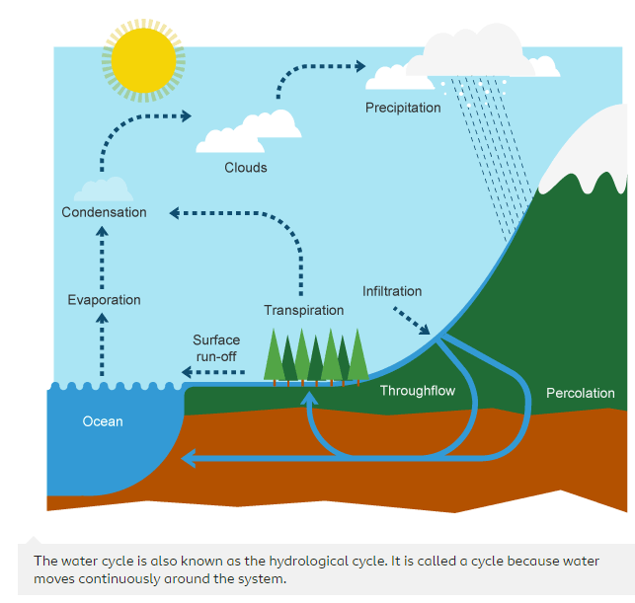
- Energy from the Sun heats the surface of the Earth.
- Water is evaporated from oceans, rivers, lakes, etc.
- The warm, moist air rises because it is less dense.
- Condensation occurs when water vapour is turned back into water droplets as it cools down. Clouds are formed.
- Precipitation occurs as water droplets get bigger and heavier they begin to fall as rain, snow and sleet, etc.

The long profile
Rivers transport water downwards because of gravity. As they move further downhill, they gather more water and become larger. Rivers can be divided into three sections: the upper, middle and lower courses. Together, these three courses form the long profile.

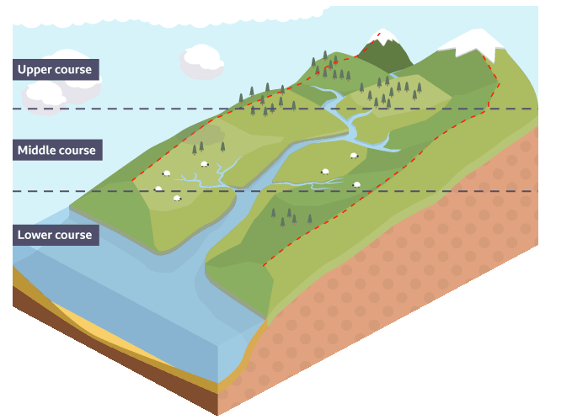
- Upper course – The start of the river at higher altitude. The river channel is small. Vertical, or downwards, erosion takes place here as water is pulled down by gravity.
- Middle course – The middle section of the river. Tributaries have joined the channel and so the river is carrying more water.
- Lower course – The final stage of the river, usually where it meets the sea. The river is wide and deep because it is carrying a large volume of water. Lateral, or sideways, erosion and deposition takes place here.

What are river processes?
Rivers shape the land by moving material from one place to another through erosion, transportation and deposition.

Erosion
When material is removed from the riverbed and banks. There are four types of river erosion:
- Attrition – rocks carried by the river collide. They break up into smaller, smoother pieces.
- Abrasion – rocks carried by the river scrape along the bed and banks. This loosens material, which is then carried away by the water in the river.
- Solution – Soluble particles are dissolved by the river.
- Hydraulic action - the force of the river against the banks. Air becomes compressed within cracks and crevices, which weakens the banks.
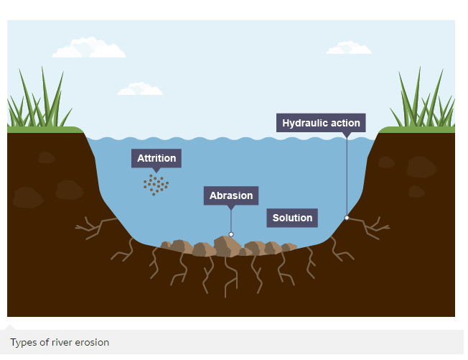

Transportation
When material is moved further downstream. There are four types of transportation:
- Suspension – smaller material that is light enough to be continuously carried along.
- Traction – large rocks are rolled along the riverbed at times of high energy, eg when the river level is high.
- Solution – very small material that is dissolved and can be transported even during times of low energy.
- Saltation – the water picks up rocks and pebbles. They are too heavy to be carried far and so they appear to bounce along the riverbed.
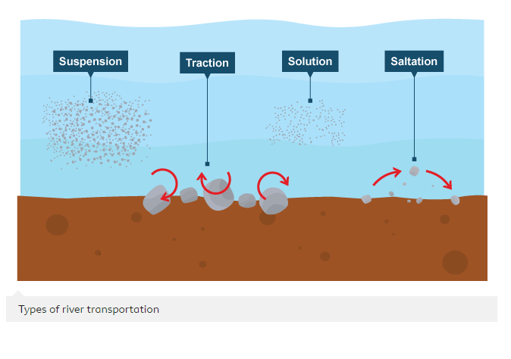

Deposition
When material is dropped by the river.
Deposition happens when river energy is low, for example when the flow of the water slows down. It can happen along any part of the river, but is common in the lower course, where the river meets the sea. Larger, heavier material is deposited first. Smaller, lighter material can often be carried during times of low energy.

https://www.bbc.co.uk/bitesize/topics/zs92tfr/articles/z66mxbk - visit this website for more information on river landforms

Key Points
- There are many physical and human causes of river flooding. They include heavy rainfall, steep surfaces, deforestation and urbanisation.
- Consequences of flooding include damage to property, loss of power, injuries and deaths. The impacts of flooding are often more severe in LICs.
- River floods can be managed using hard and soft engineering strategies. Hard engineering strategies aim to control natural processes and soft engineering strategies work alongside natural processes.

What are the causes and consequences of river flooding?

Causes of flooding
Rivers are managed to ensure that there is a plentiful supply of freshwater for use, but that any surplus water does not cause flooding which could lead to harm to people and property.
Causes of river flooding include physical and human factors.

Physical factors
- Heavy rainfall or snowmelt leads to an excess of water.
- Impermeable rocks do not allow water to soak into them and so more water flows over the land.
- Steep surfaces encourage the rapid run-off of rainwater into nearby rivers. The rivers become full very quickly and so they flood onto the surrounding land.

Sandbags can help to stop flooding in homes

Human factors
- Deforestation removes trees and vegetation that would ordinarily intercept and soak up some of the rainwater. This allows more water to enter rivers.
- Urbanisation leads to an increase in artificial surfaces, such as roads and buildings. These are impermeable and so water runs off them very quickly. This run-off can then create problems with flooding.

Deforestation makes more land for farming, settlements or roads

Consequences of flooding
Consequences of flooding include damage to property, loss of power, injuries and deaths. The impacts of flooding are often more severe in low income countries (LICs) than high income countries (HICs). This is because LICs have fewer resources and less money to deal with hazards.

River flooding is managed using flood defences. These take the form of hard and soft engineering strategies.

Hard engineering
Hard engineering strategies include measures that are usually more expensive and require artificial structures or changes to the river channel. They have an immediate impact on the river and the surrounding landscape. For example:
- building dams to control the flow of the river
- making the river channel wider and deeper so that it can hold more water
- straightening the river so that water leaves the area more quickly

Kielder dam in Northumberland

Soft engineering
Soft engineering strategies include measures that are usually less expensive and work more with the natural surroundings. They often take longer to work and will attempt to manage floods rather than prevent them. For example:
- planting trees to intercept rainfall and reduce the amount of water reaching the river
- providing flood warnings by monitoring rainfall and river discharge and alerting people to potential floods
- land use zoning, which involves using land beside the river for activities like grazing and recreation, which can be relocated during times of flood

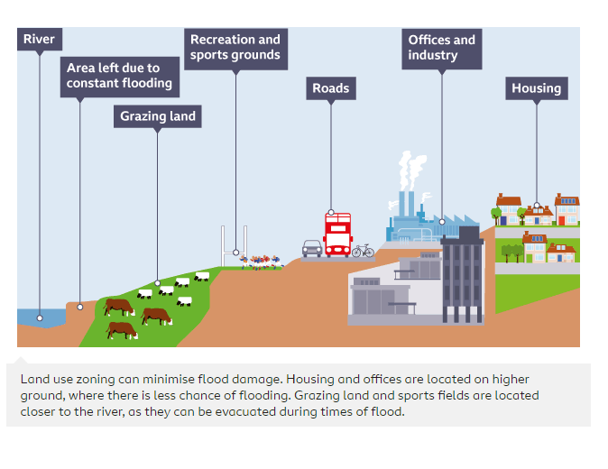

Case study: River flooding in Todmorden
Todmorden in West Yorkshire has experienced severe river flooding from the river Calder for many years. The town is surrounded by steep hillsides, making the area vulnerable to floods.
Storm Eva hit the UK on Christmas Day of 2015. Heavy rainfall led to flooding in Todmorden as well as the surrounding settlements of Hebden Bridge and Mytholmroyd. Over 3,500 homes and businesses were affected and an estimated £150m worth of damage was caused.

Flooding in Todmorden caused by Storm Ciara in February 2020

The Calderdale Flood Action Plan
The Calderdale Flood Action Plan was put together to prevent future flooding of the river. The plan included hard engineering strategies, such as:
- new flood walls
- the relocation of a bridge
- the widening of the river channel
The plan also included soft engineering strategies to absorb and store rainwater, such as:
- planting trees
- restoring the blanket bog
Unfortunately, regular floods are still affecting Todmorden and work to strengthen flood defences still takes place.

Key points
- Glaciers are large masses of frozen ice that move slowly downhill.
- As glaciers move, they wear away the surrounding land through erosion.
- Glaciers sometimes transport material over long distances before eventually depositing it.

What is a glacier?
Glaciers are large bodies of ice that cover about 10% of the Earth’s surface in cold regions such as Antarctica and the Arctic as well as in high mountain ranges such as The Alps, Andes and Himalayas.

91% of all glaciers are found in Antarctica, 8% in Greenland with the remainder being found across every continent except Australia.
There aren’t any glaciers in the UK anymore but in the last ice age, 20,000 years ago, they covered much of the country and are responsible for much of the landscape we see today.
Glaciers are made up of snow that has built up over many years. The weight of the layers of snow become compressed into ice. This process, for most glaciers, takes over a hundred years.

Due to their size and gravity, glaciers flow like very slow rivers.
As a glacier flows, weathering takes place on the land around it.
The main weathering process is known as freeze-thaw weathering. This is where water, either rain water or meltwater from the glacier, seeps into cracks in rocks and freezes solid as temperatures drop. As this water freezes it expands. If this process happens repeatedly it will weaken the rock.

Glacial processes
As glaciers move a number of processes take place. These are erosion, transportation and deposition.

Erosion
Although glaciers move very slow, they are very powerful. As they move, they erode the land around them in two ways.
- Plucking – sometimes rocks get frozen to the base, sides and back wall of the glacier. The movement of the glacier pulls these frozen rocks away.
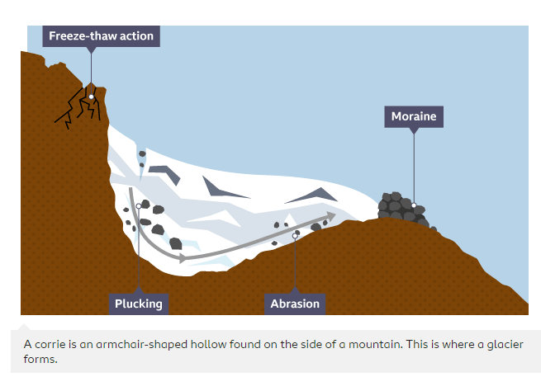
- Abrasion – rocks trapped in the glacier rub against the valley floor wearing it away like sandpaper.

Transportation
Eroded material, such as rock, is moved by the glacier. This material is known as moraine. Some is frozen inside the glacier; some is carried on the top of it and some is pushed in front. This is called transportation.

Deposition
As ice starts to melt, this moraine is dropped off and this is now known as till or boulder clay. This process is called deposition. Glaciers are capable of transporting even heavy boulders. When these are deposited they are known as erratics.

Key points
- Glaciers can form distinct landforms through erosion of the landscape such as corries.
- Glaciers also deposit material to form unique landforms such as drumlins.
- Glaciated landscapes are a source of economic activity but also of conflict.

What is a glacier?
Glaciers are large masses of ice shaped like rivers. They flow like rivers, only much more slowly. As glaciers move, they wear away the land around them through a process called erosion. The eroded material is then transported by the glacier before finally being deposited, or ‘dropped off’.
Glacial landforms are formed as a result of the erosion and deposition process. There are lots of glacial landforms that can be found in the UK, for example in Snowdonia in Wales.

Glacial landforms created by erosion
For some glacial landforms, the main process involved is erosion.

Glacial troughs
Rivers cut V-shaped valleys through the process of erosion. As rivers in their upper course don’t have that much power, they are forced to wind between harder rock leaving ridges of land jutting out. These are called interlocking spurs. Glaciers bulldoze through these valleys making them into distinctive U shapes with flat floors and steep sides called U-shaped valleys, cutting through the interlocking spurs, turning them into truncated spurs.

Once the ice has melted, long narrow lakes known as ribbon lakes can sometimes be formed. They may be created in an area where there is hard rock and softer rock. The hard rock does not get eroded but the softer rock does. Moraine from the melting glacier forms a dam in the valley and water fills up behind.

Corries
Corries are bowl-shaped hollows found on the side of a mountain. They form when the glacier deepens an existing hollow through freeze-thaw action and plucking.
As the ice moves down the mountain it does so in a circular motion which further deepens the hollow, leaving a lip at the end. When the ice melts this hollow can fill with water. These are now called corrie lakes or tarns. An example of a corrie lake is Red Tarn in the Lake District.

Arête
If corries form back-to-back on a mountain, they wear it away from both sides forming a knife edge called an arête.

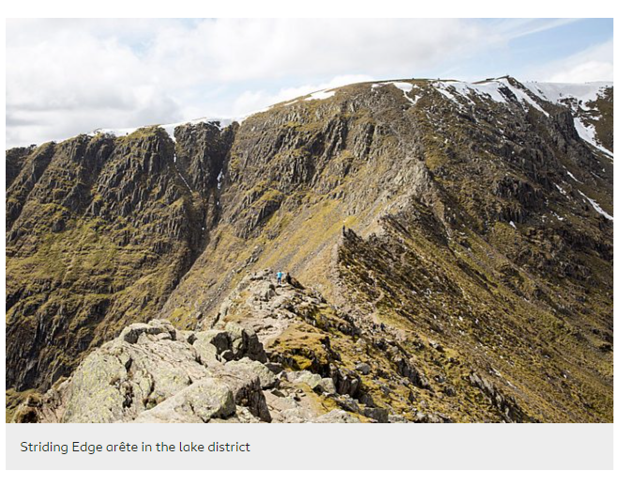

Pyramidal peak
If there are three or more corries and arêtes back-to-back, a pyramidal peak can form. This is a sharply pointed mountain peak.
The Matterhorn on the border between Switzerland and Italy is an example of a pyramidal peak.
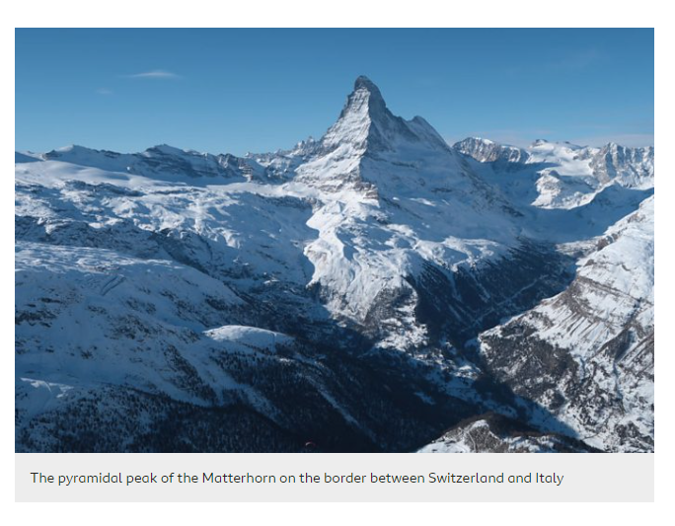

Glacial landforms created by deposition
Glaciers are very powerful and capable of carrying large amounts of rock. Eventually these will be dropped off by the glacier creating distinct landforms.

Deposition
Deposition happens when material transported by the glacier is deposited and left behind as the glacier melts or moves on.

Moraine
As the glacier moves down the mountain the air gets warmer. This causes the glacier to begin to melt. At this point everything carried by the glacier is deposited. This material is known as moraine.
There are four types of moraine:
- Terminal moraine is moraine deposited at the end of the glacier.
- If the whole glacier melts, for example as a result of climate change, then all the material is deposited. This is known as ground moraine.
- Lateral moraines are found deposited along the sides of the glacier.
- Medial moraines are found at the junction between two glaciers.

Drumlin
A drumlin is a long oval hill in the shape of a spoon made of glacial deposits. No one is really sure how drumlins form but it is thought it is caused by the ice becoming overloaded with sediment which leads to it being deposited.

How glaciated areas are used
Glaciated areas have many uses that can provide benefits to the area but can also lead to challenges.

Tourism
The landscapes created by glaciation attract tourists. The mountains provide a place where people can take part in activities such as mountain climbing, hiking and mountain biking and the lakes provide the opportunity for water sports. Sometimes tourism can cause disagreements. Local people are sometimes concerned that tourists cause traffic congestion, littering and damage whilst also pushing up house prices by buying second homes.

Farming
Although the harsh conditions of mountainous areas make most types of farming difficult, sheep farming is a common activity. Although farmland may seem like a natural environment with the green fields, they are in fact man-made. Some people believe that sheep and the clearing of the land for farming should be stopped and the land rewilded.

Forestry
Another common use of land in glaciated areas is for forestry. This is where trees are grown to be used for timber. Coniferous trees are adapted to cope with cold conditions and are perfect for upland areas. Although planting trees is good for the environment, logging companies will often only plant one type of tree leading to limited biodiversity in the area.

Quarrying
Glacial areas often contain large amounts of valuable hard rock. Quarrying takes place to extract rock such as limestone to be used for construction. This causes visual pollution as views are spoilt, noise pollution from the heavy machinery and damages habitats.

Cycle 3: Conflict

Key points
- Conflict can occur when groups of people are competing for the use of the same space or piece of land.
- The physical environment can often be the cause of conflict.
- Conflict often has an impact on the environment.

- What is conflict?
- When geographers talk about conflict, they are talking about different groups of people with competing interests fighting over a space. They may be competing for control of the space, the resources in the space or how that space is used.
- Conflict may take the form of a polite disagreement, such as a letter in a newspaper or a petition, or something more violent, such as an armed uprising or war.

- Someone signing a petition to support human rights
- Conflict can also occur at a number of different scales, from local to global.
Scale | Example
local | A disagreement over the choice of sea defence for a coastal village.
regional | Groups of people with different opinions over the building of a new reservoir.
national | A civil war over the political control of a country.
international | A political or armed conflict over the control of a territory.
global | Disagreement between nations over environmental issues such as how to deal with the threat of climate change.

The impact of conflict
Conflict has an impact on other areas of geography. For example, war or conflict can lead to environmental destruction, such as by the use of chemical or nuclear weapons or through attacks on oil facilities which can lead to the pollution of large areas of land. Destruction of crops and water supplies can lead to food shortages.
Conflict can also impact on the development of a country by committing valuable resources to the war effort rather than focussing on improvement to infrastructure.

The geography of conflict
As well as conflict affecting geography, geography can influence conflict. For example, the control of certain resources in an area may lead to war. This could be for control of energy resources, such as the role oil was said to have played in the Iraq war, or water resources as was the case in Darfur, in Western Sudan, Africa in 2003.
The conflict in Darfur is known as the ’first climate change’ conflict as one of the causes of the war in Darfur was a conflict over control of water resources between nomadic livestock herders and permanently settled farmers who farmed the land.
Climate change has led to an increase in drought and desertification meaning that these supplies were becoming more scarce. An estimated 480,000 people died in the conflict and 2.8 million people became refugees.

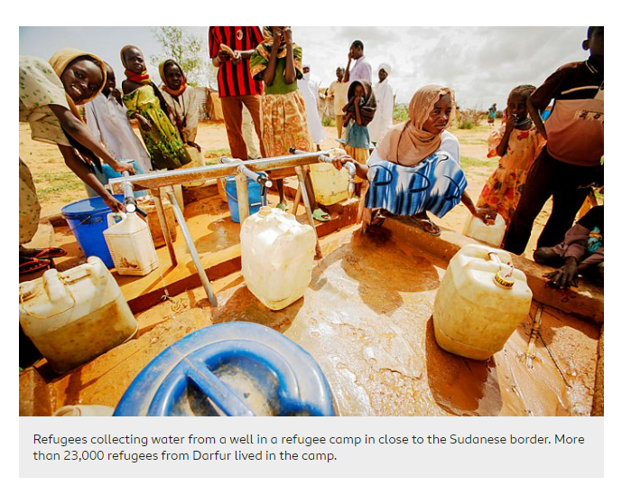

Geography can also influence the outcome of a war. For example, large mountain ranges can offer wide views over the landscape and the defensive advantage of being on high ground. A river might protect a country from attack as insurgents or armies are forced to wade across rivers, use boats or construct bridges leaving them open to attack. Wooded areas may also make it easier to hide and more difficult for the enemy to use large vehicles such as tanks.
Even climate might provide a strategic advantage for a country's success in conflict. Rain may make the ground soft, causing those on the attack to get stuck or slowed down. Harsh, cold winters, have often been thought responsible for a country’s success in defending itself against invaders, as is the case in Afghanistan. During the winter months, temperatures in Afghanistan can drop to below freezing and snowfall often makes large parts of the country inaccessible. This means that the movement of troops and supplies can be difficult.

Current conflicts
This section was written in July 2022.
International conflicts may arise between nations due to disagreements over who controls land or resources. There may also be disputes which occur as a result of a political argument or over rights to control territories.
Current conflicts include:
- Ukraine – Ukraine was invaded by its neighbour Russia in February 2022. There has been conflict between the two countries since 2014, when Russia invaded and took control of the Crimean peninsula, which is a part of Ukraine. Relationships between Russia and its neighbouring countries have been complex since the USSR collapsed in 1991. At least 12 million people have fled their homes in Ukraine in 2022 (United Nations figures correct in July 2022).
- Syria – Since an uprising began in 2011, there has been a civil war in Syria. It started when Syrian citizens began protesting against high unemployment, hyperinflation, corruption and a lack of political freedom. Many foreign countries have since supplied arms and aid to the various factions fighting the civil war.
- Yemen – The president of Yemen fled the country in 2014 when Houthi Shia Muslim rebels took control of the capital Sanaa. Since 2015 Saudi Arabia and eight other mostly Sunni Arab states have conducted air strikes against the Houthis, with the aim of restoring the government. It is estimated that 74 per cent of the population of Yemen are in need of humanitarian assistance.

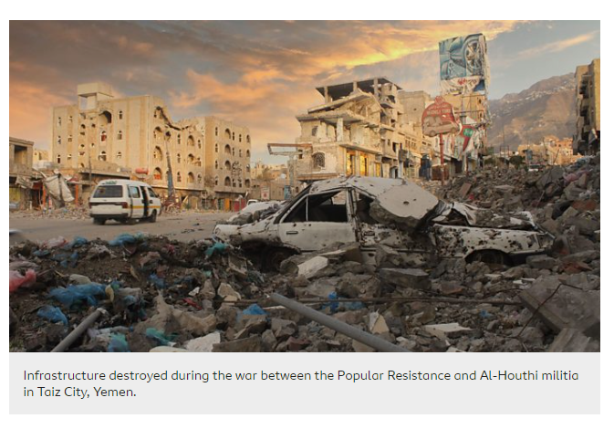

Conflict can slow down a country's rate of development This means that many citizens may suffer due to a lack of investment in their healthcare, education and infrastructure.

