Year 9 End of Year Geography Revision
Cycle 1: Population and the Environment

Key points
- Different countries produce different types of food, which they trade with one another. Although there is enough food to feed everyone, it is not evenly spread.
- Global food consumption is increasing. As countries become wealthier, their populations eat more.
- Food insecurity is a major issue in some countries. It can lead to hunger, soil erosion, rising prices and conflict. Many factors determine our ability to grow enough food.

Where does food come from?
Different countries produce different types of food, which is often dependent on their climate. For example, Asian countries grow rice, African countries grow cocoa, South American countries produce oil crops, and European countries produce a lot of milk and fish. Of all arable land in the world, around half is farmed.
Modern food production allows some, but not all, of the world’s population to enjoy a varied diet throughout the year. For example, it is possible to eat strawberries in winter in the UK. This scale of food production can have negative impacts on people, animals and places.
Increasing food miles adds to global climate change. This is because fuel is required to move food between countries, which leads to increased carbon emissions.

What are the causes of food insecurity?
There is enough food to feed everyone, but it is not evenly spread, and some countries have food insecurity. The population in HICs such as the United Kingdom is consuming more food than it needs, which can lead to problems such as obesity. LICs, like Niger, in Africa, have less food than they need which leads to malnutrition.
Average global food consumption is increasing. The world’s population is growing at a rate of 1.08 per cent per year, meaning there are around 80 million additional people to feed each year. Also, as countries become wealthier, their populations eat more as they have more money to spend on food.
The global supply of food is affected by several factors.
- global temperatures and rainfall (climate)
- technology
- political unrest or conflict
- pests and diseases

What are the effects of food insecurity?
- Millions of people go hungry each year and may not be able to eat for extended periods.
- Farmers try to produce more food. Trees are cut-down to make more farmland and more cattle are squeezed into fields. This causes soil erosion and deforestation.
- When the demand for food exceeds the supply, prices increase. Many of the most vulnerable people cannot afford to eat.
- Food is a basic human need. Food shortages can lead to conflict.

Key points
- Sustainable fishing involves allowing fish stocks to repopulate our seas. Sustainable meat production involves rearing animals on grass, without the use of hormones.
- Sustainable food production involves cultivating the land whilst also protecting it for future generations.
- Other ways to sustainably increase food supplies include organic farming, urban and peri-urban horticulture, reducing food waste, and eating food that is in season.

What is sustainable fish and meat production?
Sustainable food production involves farming the land whilst also protecting it for future generations.

Fish
Sustainable fishing involves allowing fish stocks to repopulate our seas. This means fewer fish are caught at any one time, ensuring there will be enough fish for the future.
Catching fewer fish can be achieved through a better design of fishing nets that have holes that allow smaller fish to escape. Smaller fish can then grow and repopulate the oceans.

Meat
Some farmers feed grain to animals, as opposed to grass, as it increases their weight and heavier animals can be sold on for more money. This results in further deforestation in order to create the farms to grow the grain. Likewise, some cattle are given hormones to make them grow more quickly. Sustainable meat production involves rearing animals on grass rather than grain, without using hormones.

How else can food supplies be increased sustainably?
As well as meat and fish, various other types of food can be produced in a sustainable way.

Organic farming
Organic farming relies on natural products and processes. These include:
- natural fertilisers, such as manure, rather than chemicals.
- using natural predators, such as ladybirds, to control pests like aphids.
- crop rotation, which allows soils to recover

How do countries manage their population?
Governments sometimes create policies to manage their population. They may try to increase birth rates, and therefore the population, by encouraging people to have children through pro-natal policies. Alternatively, they may try to decrease the birth rate, and slow the rate of population growth, by discouraging people from having children through anti-natal policies.

United Kingdom
Pro-natal strategies are used in the United Kingdom to try and boost fertility rates. These include incentives such as child benefit payments, free childcare, and improved maternity and paternity leave. There are also family-friendly employment laws such as the right to request flexible hours and job sharing.

Pro-natal policies are policies designed to increase the birth rate.

China
In the 1970s, China attempted to reduce the country's birth rate and slow the population growth by introducing the one-child policy whereby families could only have one child. The policy did slow population growth but also had some negative impacts. The policy led to a decrease in human rights because people were not allowed to make decisions about the size of their families. China now has an ageing population which threatens to slow economic growth as the number of working-age people decreases. China has made some changes to their policy and, as of 2021, families are now allowed to have three children.

Kerala, India
The state of Kerala in India also faced high population growth. This was creating many problems, such as overcrowding and a shortage of food. The government have now slowed this population growth through a mixture of contraception use and the introduction of government policies to improve education and healthcare, especially for women. Improvements in education have also led to infant mortality rates falling. This has meant that Kerala has managed to control its population growth without restrictions on family size.

In Kerala 85 per cent of women can read and write. Improvements in education have led to infant mortality rates falling.

Key points
- There are different reasons why people migrate, such as for work opportunities or to seek safety.
- Migration is influenced by push and pull factors.
- Migration of people can happen both between different countries, and within the same country.
- Migration can have a number of effects on both the host and source countries.
Why do people migrate?
- Migration is the movement of people from one area to another. This may be temporary or permanent and may be international or within a country.
- The decision to migrate is often a difficult one and one taken out of dire need, for safety, or for the hope of a better life. The reasons why people choose to leave one area and go to another are known as push and pull factors. Push factors are things which make people want to leave and pull factors are things attracting them to the new location. Often the decision to move from one area to another is based on a mix of both push and pull factors.

- Push and pull factors which can cause migration

Push factors
- A person may choose to leave their area or country voluntarily, or they may be forced to leave. For example, refugees and asylum seekers may be forced to leave to escape a war or conflict.
- People may also have to leave a country as a result of a natural disaster. In the aftermath of the May 2021 Mount Nyiragongo volcanic eruption in the Democratic Republic of the Congo (DRC) for instance, around 400,000 people were forced to flee the Congolese city of Goma. Thousands of those people entered neighbouring Rwanda, where they stayed in the border city of Gisenyi.

Pull factors
People may choose to voluntarily leave their area or country to improve their standard of living. These people are known as economic migrants. They may move from a low-income country to a high-income country or from a rural to an urban area in the same country in the hope of finding a better paid job. Although this is classed as voluntary migration, some people may feel forced to move to support their families.

The effects of migration
Migration can have consequences for both the host and the source countries and these can be both positive and negative.

Positive impacts of migration for source country | Negative impacts of migration for source country
Reduction in unemployment. | As the population decreases, so too does the amount of money received from taxation.
Less demand for services such as healthcare in the country due to the now lower population. | Those who leave are often those who are highly skilled and educated, leaving fewer skilled workers in the source country. This is known as ‘brain drain’.
Money sent back home from the host country can help boost the source country’s economy.

Migration can enrich a country by bringing new cultures and cuisines. Chinatown in London has been at its present site in the West End since the 1950s.
Positive impacts of migration for host country | Negative impacts of migration for host country
Skilled workers arriving in the host country means shortages can be filled without having to invest in training people to fill these roles. | Large numbers of people coming to a country all at once may lead to environmental impacts as the migrants compete for resources. An increase in migrants to one place can increase the levels of pollution in that area.
More money is paid to the government in taxes and more money is spent in businesses, providing a boost to the economy. | Increased competition for jobs may lead to a rise in resentment and potentially conflict between migrant workers and locals.
Attracting younger workers is a way of coping with an increasingly ageing population.
An exchange and appreciation of cultures and a multicultural society.

Cycle 2: Hazards

Key points
- The Earth is made of different layers: the core, mantle and crust.
- Plate tectonic theory shows that the crust of the Earth is split into plates (pieces of the Earth’s crust).
- The movement of these tectonic plates leads to earthquakes and volcanoes forming.

The structure of the Earth
The Earth is made up of different layers:
- core (divided into the inner core and the outer core)
- mantle
- crust
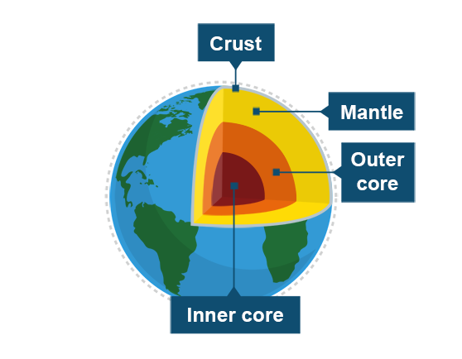
Layer | Description
Inner core | The inner core is 2900 km below the Earth’s surface, in the centre of the Earth, and is the hottest layer. It is spherical and solid and made up of iron and nickel. Its temperatures can reach 5500°C.
Outer core | The outer core is the layer surrounding the inner core. It is made of liquid iron.
Mantle | The mantle is the layer of the Earth which makes up 84% of its volume. It is also the thickest section at approximately 2900 km thick. The mantle is made up of different layers. The upper mantle is hard but below that is semi-molten rock called magma.
Crust | The crust is the outer layer of the Earth on which we live. It is the thinnest layer and is between 5 and 90 km thick.
The crust of the Earth is not made up of one solid piece – it is split into plates which float on the upper portion of the mantle. There are two types of plate:
- dense oceanic crust
- less dense thick continental crust
These plates move slowly and either move apart, towards or past each other.
The point at which these plates meet is known as a ‘plate margin’. It is at the plate margins where the most tectonic activity and tectonic hazards, such as volcanoes and earthquakes, occur.

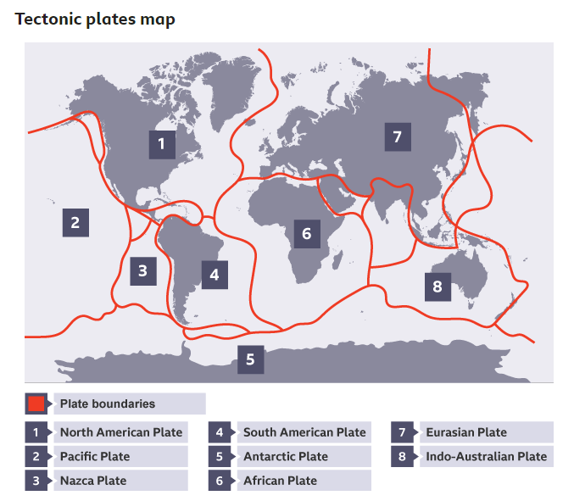
There are two theories as to why these plates move. The first, and most common, theory is that the plates move due to convection currents in the Earth’s mantle. This is where the heat from the Earth’s core causes magma to rise. As it nears the Earth’s surface, it then cools and sinks. This circular motion causes the plates in the crust to move.
The second theory is known as ‘slab pull’ where it is thought that the movement is caused by the weight of heavier denser plates sinking into the mantle and dragging other sections of the plate with it.

Key points
- A volcano is a hazard caused by plate tectonics.
- Volcanic eruptions have both primary effects (such as the destruction of buildings) and secondary effects (such as homelessness).
- There are ways of reducing the effects of volcanic eruptions by, for example, planning, predicting and preparing.

Volcanoes
A volcano is an opening in the Earth's crust. Ash, magma and gases escape from this opening. Volcanic eruptions can be a hazard to people and the environment.
Volcanoes occur either at the unstable boundaries of tectonic plates or in the middle of plates where the crust is thin or where there is a particularly hot spot in the mantle.

Effects of volcanoes
A volcanic eruption can cause a variety of effects. These can be classed as primary or secondary effects. Primary effects are caused by the volcanic eruption whereas the secondary effects are caused by the primary effects.

Primary effects
- As the volcano erupts, streams of molten rock called lava flow from the volcano causing damage to habitats and property.
- Pyroclastic flows are flows of super-heated gas and ash. These can travel at hundreds of kilometres per hour.
- Ash fall from volcanoes can land on the roofs of buildings causing them to collapse.

Secondary effects
- Volcanic eruptions can lead to climate change. Ash from volcanoes can reflect the sun’s energy and lead to cooling, the carbon dioxide released can contribute to global warming.
- Roads can become blocked by solidified lava flows making it difficult to travel around.
- There can be positive effects of volcanic eruptions. Ash from the volcano can act as a fertiliser for soils.

Why do people live near volcanoes?
There are a number of reasons why people choose to live near volcanoes:
- Geothermal energy can be harnessed by using the steam from under the ground.
- Many people can visit the area, creating a tourism industry.
- The soil around volcanoes is rich in minerals and therefore creates excellent agricultural land.

Response to volcanoes
After an eruption the country must respond. Some responses will happen very quickly (immediate responses) and some may go on for months or years (long-term responses).

Immediate responses
- Evacuating residents from the area is a priority following a volcanic eruption, or before, if an eruption has been predicted.
- Setting up exclusion zones, areas where people are not allowed to go, can help to reduce the number of deaths.
- Providing medical care to those injured.

Long term responses
- Rebuilding of damaged buildings and infrastructure must take place.
- Resettling people affected by the eruption. This may mean building new houses or even moving people to a whole new location.
- Installing monitoring equipment.

Risk reduction
Countries can try to reduce the risk of damage from volcanic eruptions by attempting to predict when they might occur, protecting their buildings and preparing their population for what to do in the event of an eruption. The extent to which a country can do this depends on their level of development. A high income country can spend more than a low income country meaning the effects would be reduced more.

Prediction
It is much easier to predict volcanic eruptions than earthquakes. Monitoring the area for seismic activity, changes in shape of the volcano and gas emissions can all help to predict when an eruption may occur.

Protection
There is little that can be done to protect buildings or land from a volcanic eruption but it may be possible to restrict what can be built in at-risk areas. For example, an area that is high-risk may have restrictions that do not allow the building of homes.

Preparation
By training people on what to do in the event of an evacuation people can prepare for an eruption. This may involve drills in schools or advising people to pack survival kits.

Key points
- There are a number of hazards caused by plate tectonics including earthquakes and tsunamis.
- Earthquakes have both primary effects (such as the destruction of buildings) and secondary effects (such as fires, water contamination, or spread of diseases) .
- There are ways of reducing the effects of earthquakes by, for example, planning, predicting and preparing.

Earthquakes

What is an earthquake?
An earthquake is a sudden, violent shaking of the ground. An earthquake occurs when two tectonic plates push together. The pressure of these colliding plates builds up inside the Earth’s crust. The point in the crust where the pressure is released is called the focus. The point on the Earth's surface above the focus is called the epicentre. When the pressure is too much it is suddenly released and waves of energy, called seismic waves, occur. These seismic waves travel through the earth causing it to shake.
Find out more about tectonic plates.

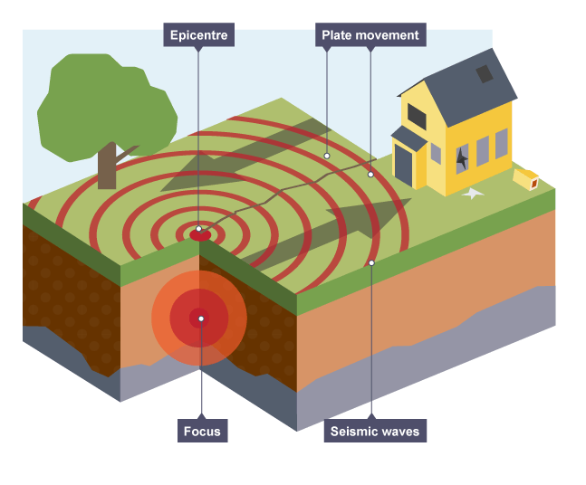
The shaking of the ground caused by an earthquake can cause a variety of effects. These can be classed as primary or secondary effects. Primary effects are caused by the earthquake itself, whereas the secondary effects are caused by the primary effects.

Primary effects
- Buildings may collapse due to the shaking of the ground.
- People may die if they are inside a building when it collapses.
- Roads may be blocked, gas and water pipes could be broken and electricity could be cut off.

Secondary effects
- The cost of rebuilding may be high.
- Trade will decrease, especially if the infrastructure (roads, airports etc) have been damaged.
- Spread of diseases may rise. If dead bodies are left in the open for a long period of time they can cause a risk of infectious diseases, such as tuberculosis and hepatitis B.
- Poor sanitation may occur if water pipes were broken during the earthquake.

- Earthquakes at sea cause water to be displaced, creating a fast-moving wave that spreads out in all directions. In the deep ocean, tsunami waves can reach speeds of up to 800 kilometres per hour. As the wave approaches shallower waters near to the shore, its speed will decrease but the waves will become higher.
- These waves cause flooding and the majority of the deaths associated from tsunamis are caused by drowning. The flooding can contaminate water supplies and cause the destruction of homes.
- The flooding can also lead to secondary effects such as causing illnesses in the area. These illnesses are due to poor sanitation and lack of clean water because of contaminated water supplies due to flooding. Flooding washes into clean water supplies carrying debris and sewage.
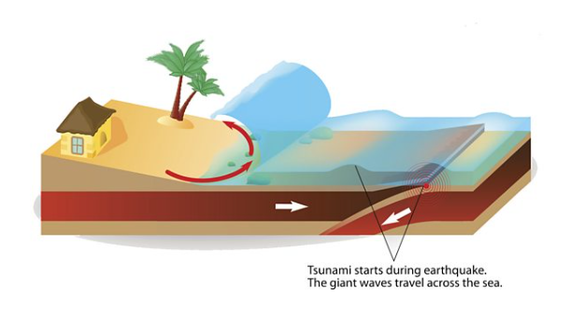
- A sudden shift in plate movement causes water displacement at the epicentre.
- Large waves move along the seabed away from the epicentre.
- As the waves move from deep water to shallow water near the coastal area, they increase in height and break.

Responses to earthquakes
After an earthquake the affected country must respond. Some responses will happen very quickly (immediate responses) and some may go on for months or years (long-term responses).

Immediate:
- People are rescued from destroyed buildings.
- People are evacuated.
- Emergency shelters are put in place.

Long-term:
- Reconstruction of destroyed buildings will take place.
- Infrastructure such as roads repaired.
- Temporary housing is provided.

Risk reduction
Countries can try to reduce the risk of damage from earthquakes by attempting to predict when they might occur, protecting their buildings to make them earthquake proof and preparing their population for what to do in the event of an earthquake.

Prediction
It is impossible to predict with certainty when an earthquake will happen but scientists can try in a number of ways. Using historical records GPS and seismographs to measure small tremors scientists can predict where they believe earthquakes will occur. There has been some evidence that monitoring changes in animal behaviour could be a way to predict imminent earthquakes and seismologists in China have monitoring stations in zoos for this reason.

Protection
The most effective way to reduce risks is earthquake protection. Buildings can be constructed to resist the shaking associated with earthquakes. This can be done with counterweights that correct the movement of the building and cross-bracing to reinforce the structure, as shown in the image below.

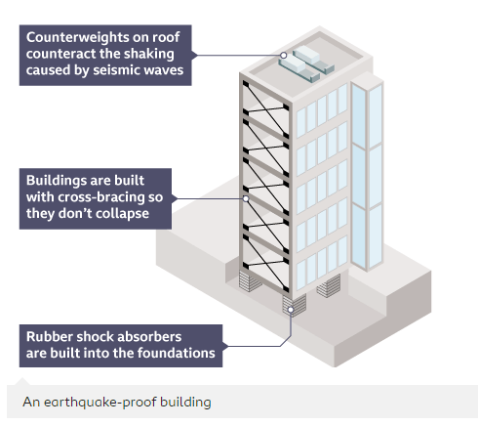

Preparation
By training people what to do in the event of an earthquake, countries can increase the chances of survival in the event of an earthquake. This can be in the form of earthquake drills in schools or training emergency services on how to respond.

How earthquakes impact countries
Natural hazards, such as earthquakes, can cause more damage in low incomes countries (LICs) than in high income countries (HICs).
HICs may have invested money and training into preparing the citizens of a country in evacuation methods, as well as increasing the stability of buildings and being able to invest in earthquake precautions when constructing new buildings.
However, LICs are less likely to have the money and resources to prepare for these natural hazards. Therefore when the hazard strikes, they are greatly affected. An example of this is the 2010 Haiti Earthquake that killed over 200,000 people, largely due to weak buildings collapsing.

Key points
- Tropical storms form over warm oceans and travel from east to west.
- Tropical storms bring with them high winds, rain and storm surges.
- Tropical storms can cause large-scale damage and danger to life.

What are tropical storms?
Hurricanes, typhoons and cyclones are all names used to refer to violent, rotating, tropical storms.
The term for these storms changes, depending on where they occur. If they form over the Atlantic Ocean or the Eastern Pacific Ocean, they are called hurricanes.
If they occur in the Far East, near places such as Japan, they are known as typhoons and if they occur in the Indian Ocean they are known as cyclones.

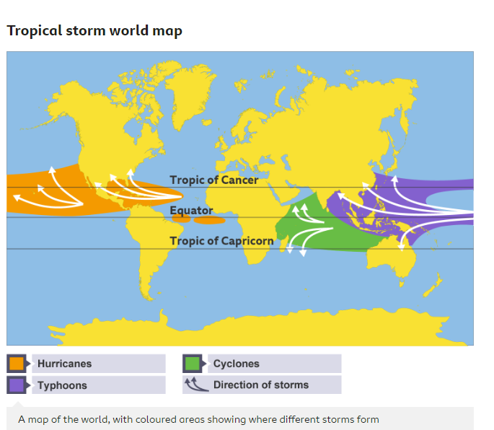

How tropical storms form
For a tropical storm to form, there needs to be a warm ocean (27 °C or above) and light winds.
As tropical storms require warm oceans, they are normally found in tropical regions between 5° and 30° north and south of the equator where the water is warmest.
They usually form in the late summer when sea temperatures are at their highest.

The formation of a tropical storm
- Step 1: Warm air rises from the ocean. As the warm air rises it leaves a space below it called an area of low pressure. This space is instantly filled by surrounding air rushing in causing strong winds.
- Step 2: The air that has rushed in now warms up and rises too. This rising air brings with it moisture. This moisture cools and condenses to form towering storm clouds. This forms the eye wall.
- Step 3 – When the cooled air descends it will form an area of calm in the centre called the eye.
- Step 4 – Due to the winds near the equator the tropical storm starts to move from east to west. The spin of the Earth causes these winds to curve and leads to the storm starting to spin.
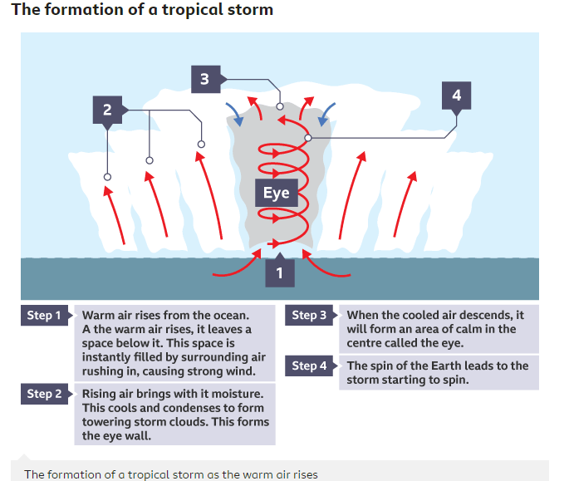

Scientists believe that climate change may affect tropical storms.
As the Earth warms so to do the oceans. If more of the oceans are above 27 °C, more places may experience tropical storms. Higher temperatures may also mean more energy for a tropical storm meaning they become more powerful and cause more damage.

Impact of tropical storms
A tropical storm can last up to a month and move very slowly, about 15 mph, across the ocean. On average seven hurricanes form each year over the Atlantic Ocean. Not all of these tropical storms make it to land; an average of two a year do.
If a tropical storm does make landfall, it can have devastating effects on both people and the environment. These effects can be divided into primary effects and secondary effects.

Primary effects
Primary effects are caused by the tropical storm itself, usually as a result of high winds and the storm surge that often accompanies a tropical storm.
Primary effects may include:
- Strong winds, heavy rain and storm surges lead to buildings being destroyed or flooded.
  - Hurricane Dorian which hit the Bahamas and mainland USA in 2019 was the most powerful Atlantic hurricane on record with winds at 185 mph (295 km/h).
- Roads, railways, electricity supplies and other infrastructure being damaged.
- People being killed.
  - Hurricane Katrina hit the United States in 2005 and killed more than 1800 people.

Secondary effects
Secondary effects are caused by the primary effects and usually happen later on.
Secondary effects may include:
- food and clean water shortages
- jobs being lost as businesses are damaged
- costs of damage
- landslides which can cause people to become homeless and cause evacuation difficulties for the emergency services

Key points
- Tropical storms can cause devastation to a region which will require responses.
- The responses can be immediate, such as rescuing people, or long term, such as rebuilding infrastructure.
- How well a country responds will depend on the wealth of a country.

Responses to tropical storms
A tropical storm can cause devastating effects due to the high winds and storm surges. These effects require government action plans in the form of either immediate or long-term responses.

Immediate responses
Immediate responses happen either before the storm hits or immediately afterwards. These may include:
- evacuation of residents
- emergency services rescue those who are injured or in danger
- aid is provided by governments and NGOs to provide food, water and medical care
- temporary shelter is set up for people who have had to evacuate their homes
- digital maps are used during and immediately after the storm using satellite photographs to advise on evacuations and support emergency services in rescues

Long term responses
Long term responses take place in the weeks, months and years after the storm and aim to repair the area affected and protect it from further storms. These may involve:
- repairing damaged infrastructure
- strengthening and repairing flood defences
- rebuilding property damaged and rehousing the homeless through rebuild and repair schemes funded by the government
- improving forecasting and monitoring systems allowing for better prevention of damage
- changing building regulations so that properties and infrastructure can withstand the impacts of a tropical storm

Reducing the risk
Tropical storms can be devastating and it is, therefore, a priority for a lot of nations to attempt to reduce the risks associated with tropical storms. This can be done by using the ‘three Ps’:
- Planning
- Prediction
- Protection

Planning
- Training emergency services how to react to a storm can reduce the number of deaths.
- Planning evacuation routes can allow people to get away from the storm quicker.

Protection
- Buildings can be made to withstand tropical storms. They can be put on stilts to lift them out of floodwater or be built with reinforced materials to prevent wind damage.
- Levees and sea walls can be built to prevent flooding.

Factors affecting risk
Several factors can affect the level of risk a country has from a tropical storm.
For example, if the area is heavily urbanised and densely populated there may be more risk, especially in low-income countries (LICs) where the urban poor often live in low-quality housing.
One reason for this is that the concrete used to build roads and buildings does not allow water to soak in, leading to greater flooding as the water runs quickly into rivers. On the other hand, in rural areas where the land is often covered with grass and plants, water soaks into the ground.
The level of development can have a big impact on the effects of and responses to a tropical storm. Low-income countries (LICs) are more at risk and 90 percent of victims from natural disasters are from low-income countries. This may be because a low-income country may not be able to afford the defences needed to protect against a storm or be able to invest in prediction methods.
For example, Hurricane Matthew struck the Caribbean country of Haiti on October 4, 2016 causing 546 deaths. Haiti is one of the poorest countries in the world and despite being in the path of regular hurricanes it lacks the defences needed to protect itself.

Residents trying to clear a river blocked by debris after Hurricane Matthew in Haiti
If a country has a high income then they will be able to spend more on emergency services but this may not be the case in a low-income country. For this reason, the death toll and amount of damage caused is often higher in LICs.
The United States for example, despite experiencing a number of hurricanes each year can invest in flood defences such as levees and early warning systems resulting in a lower death toll.

Case study - Hurricane Sandy
Hurricane Sandy was a tropical cyclone which occurred in October 2012. It started off the coast of West Africa, travelled across the Atlantic Ocean, through countries such as Cuba, Haiti and The Bahamas before hitting the east coast of the USA.

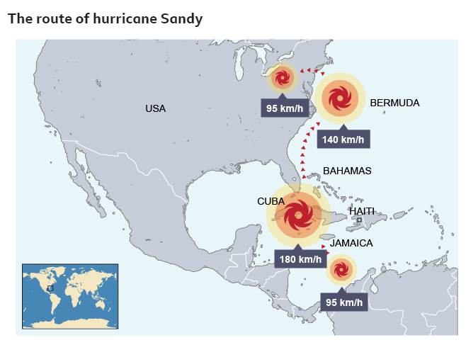

Responses
The responses to Hurricane Sandy were varied.
In LICs like Haiti there was insufficient prediction, planning or protection due to a lack of resources.
In contrast, HICs like the USA, had better prediction, planning and protection. The National Hurricane Centre in Miami predicted and monitored the path of Hurricane Sandy and issued warnings which reduced the impact of the storm in the USA:
- Police evacuated hundreds of thousands of people from low-lying coastal areas most vulnerable to Hurricane Sandy.
- Schools and public transport services closed down.
- People temporarily relocated to evacuation centres.

Impacts
- Economic – At the time Hurricane Sandy was the second most costly hurricane on record after Hurricane Katrina, causing $71 billion in damages. In New York City, economic losses are estimated at exceeding $18 billion.
- Social – In Washington DC and other cities, many supermarkets ran out of essentials such as bottled water and batteries as people prepared for the worst.
- Environmental – More than 70 per cent of crops, including bananas and maize, were destroyed in the south of Haiti.

Cycle 3: Urbanisation

Key points
- Cities in high-income countries (HICs) have grown over a long period of time. The growth of HIC cities has been mapped out using land-use models, such as the Hoyt (or Sector) Model.
- Cities in HICs grew during and after the Industrial Revolution. Population growth in HIC cities is now lower and some are even experiencing population decline.
- Cities in HICs grew outwards along radial routes. The oldest parts of a city are found in the centre.

What are cities in HICs like?
High-income countries (HICs) are those recognised by the World Bank as being wealthier. Cities in HICs are often well-established and have grown over a long period of time. Some have existed since the Roman times. Many cities in HICs developed around a specific function, for example a port. They typically contain historic landmarks, businesses, shopping areas and a variety of housing types.

Liverpool is an example of a city in a HIC - England.

The Hoyt Model
The layout of HIC cities are represented using land-use models. The Hoyt (or sector) model was mapped out in 1939. It shows a basic pattern:
- The central business district (CBD) in the middle. Land values in the CBD are high, so the most profitable shops and businesses locate here.
- Factories and industries develop along transport routes.
- Low-cost housing lies close to the CBD (where plot sizes are small) and beside the industry.
- More expensive housing lies further away, where larger plot sizes allow space for gardens and garages.
Whilst the Hoyt Model shows general trends, it is largely outdated. For example, more expensive housing is now found in redeveloped industrial areas of HIC cities, for example the harbourside area of Bristol.

How have HIC cities developed over time?
HICs are urbanised. This means they have a greater percentage of people living in urban than rural areas. HIC cities are located around the globe. Examples include New York in the USA, Montevideo in Uruguay, London in the UK, Seoul in the Republic of Korea, and Sydney in Australia.

History of HIC city growth
The transatlantic slave trade took place between the 1500s and 1800s. European colonial powers enslaved African people and forced them to work on plantations. Profits from slavery allowed port cities like London, Bristol, Glasgow, and Liverpool, to grow and become wealthier. Find out more about the transatlantic slave trade here.
Many believe that the wealth from slavery enabled the Industrial Revolutionto take place. Cities in HICs grew during and after the Industrial Revolution. People moved from the countryside to cities looking for work in factories.
Lots of people now work in offices or work remotely. Office and remote working can take place anywhere and so people do not have to live in cities. Population growth in HIC cities is now lower and some are even experiencing population decline.

Patterns of HIC city growth
Cities in HICs grew outwards, with the oldest parts of the city found in the centre. Historic structures, like city walls and cathedrals, are found here. Cities grew outwards along radial routes that led into the surrounding countryside. As more buildings were constructed, space in the centre became limited and land values increased. The high cost of land led to developers building upwards, and so taller buildings and skyscrapers are often located in city centres.

Key Points
- Towards the end of the 20th century, many people in high income countries (HIC) moved away from city centres.
- Some HIC cities are now experiencing reurbanisation. This has led to the redevelopment of certain areas of the cities.
- Cities in HICs have many challenges that require careful management. These include congestion, waste disposal, energy use, pollution and access to green spaces.

Moving away from the city
In the late 20th century, many people moved out of certain areas within HIC cities in search of more space and a better quality of life. This led to an increase in the number of people living in the suburbs or in rural areas.
When people move to the edge of towns or cities, known as the suburbs, this is called suburbanisation. The benefits of the nearby city or town can be enjoyed, without living in its centre. However, some people leave the city completely. This is called counter-urbanisation. This has become more popular with the ability to work from home, sometimes known as remote working or teleworking.
The growth of London, for example, is beginning to slow down.

Suburbs contain houses, shops and offices

Moving towards the city
Some cities are now experiencing reurbanisation as people are drawn back to living in the city. Many areas that were derelict, such as factories, have now undergone redevelopment and gentrification. Cleaner air, better transport systems and more opportunities for entertainment and recreation have attracted a new, younger population to settle in these areas. HIC cities can now offer a better quality of life than before.
Manchester, for example, has recently seen an increase in people living in the city centre.

Trams are a form of public transport

How are the challenges of HIC cities overcome?
HIC cities have many challenges that require careful management. These include:

Waste disposal

A waste incinerator
Recycling centres decrease landfill. Some cities operate Energy Recovery Facilities (ERF) which incinerate waste to produce electricity.

Congestion
Sustainable transport systems encourage public transport use. Examples include integrated bus, tram and train networks, cycle lanes and congestion charges.

Pollution

Bangkok city covered in smog
Many cities have introduced laws to improve air quality. Advances in vehicle technology and incentives for using cleaner transport, such as electric vehicles, have reduced air pollution.

Energy use
New technology has led to energy efficient buildings. Measures such as improved insulation and the use of solar panels have decreased energy demand in cities.

Access to green spaces
Urban greening brings social, economic and environmental benefits. Access to green spaces can also improve mental health

rban Greening

- Urban greening has increased the amount of green space in cities. Examples include green roofs, tree-planting schemes, parks and other open spaces.

- Green leaves absorb less heat than building materials. During the summer months, the air around green space is cooler than the air around buildings.

- Roots of plants take up some of the rainwater that would have run into drains. This means that green spaces reduce flood risk.

- Plants provide habitats for lots of different insects. Green spaces are good for biodiversity.

- Open spaces provide areas for social interactions, recreation and tourism. They are good for physical and mental health and the local economy.

Key points
- Cities in low income countries (LICs) and middle income countries (MICs) began to grow rapidly in the 20th century.
- In LICs, more people still live in the countryside. In MICs, around half of the population now live in cities. In both types of country, the percentage of those living in cities is increasing.
- Urbanisation in LICs and MICs is caused by rural to urban migration and natural increase (when birth rates are higher than death rates, leading to an increase in population).

How is land used in different types of cities?
Cities in low income countries (LICs) and middle income countries (MICs) began to grow rapidly in the 20th century. The growth of LIC and MIC cities has been mapped out using a land use model.
Land use in LIC and MIC cities can be similar to cities found in high income countries (HICs) cities. However, there can also be some major differences. Here are some similarities and differences between land use in LIC and MIC cities compared to HIC cities.

Similarities
- The central business district (CBD) is in the middle of the city. Land values in the CBD are high, so the most profitable shops and businesses are located there.
- Factories and industries develop along one or more transport routes such as ports or roads.
- High-cost housing is found close to the CBD and along some transport routes. These are planned areas with water and sanitation.

High-cost housing close to the CBD in Mumbai, India

Differences
- Informal settlements grow around the edges of LIC and MIC cities on land that is marginalised. They are often deemed illegal as residents do not own the land.
- Basic housing is found further away from the CBD, where land values are cheaper.

Many new migrants to Manilla in the Philippines live in informal settlements

Land use in LICs and MICs
Land use models are just a representation of what a typical city looks like. Not all cities have the same pattern of land use.
The land use model for MICs and LICs has the Central Business District (CBD) in the centre. High-cost housing is found close to the CBD and along some transport routes. Informal settlements are found around the edge of the city, where land values are lower.

How have cities in LICs and MICs developed over time?
As countries become wealthier, they tend to become more urbanised. In LICs, more people still live in the countryside. In MICs, around half of the population now live in cities. In both types of country, the percentage of those living in cities is increasing.
Eight of the top ten most populous cities in the world are now found in LICs and MICs. These are all megacities that are still growing. Examples include Delhi in India, Shanghai in China, Cairo in Egypt and Lagos in Nigeria.

What causes urbanisation in LIC cities?
Urbanisation in LIC cities is caused by:
- Rural to urban migration - People move to cities for better opportunities. These include jobs, access to electricity and improved sanitation.
- Natural increase - Fertility rates in LICs and MICs have declined over the last 40 years. However, birth rates are still higher than death rates. This means that the population of these cities tends to increase over time.

Key points
- Cities in low income countries (LICs) and middle income countries (MICs) are growing through rural to urban migration. Many migrants live in informal settlements.
- Although many cities in LICs and MICs are now important economic hubs, the poorest people still do not benefit from the increased wealth. Poorer residents often live in overcrowded informal settlements.
- Cities in LICs and MICs have many challenges that require management. These include poor quality housing, lack of clean water and sanitation, access to health services and education, and meeting energy needs.

How are cities in LICs and MICs changing?

Living conditions
Rates of urbanisation are higher in low income countries (LICs) and middle income countries (MICs) than in other countries. Migrants moving from rural to urban areas sometimes build informal settlements on marginalised land around the edge of the city. These have improved over time and many, such as Iwaya in Lagos, are now well-establishedneighbourhoods .
In some countries, governments have granted residents ownership of the land, and have installed water and sanitation systems. This can be seen in Dharavi, where India's largest community toilet block opened in 2022. The two-storey building provides 111 toilets, a clean water supply, and bathing and laundry facilities.

Dharavi, an informal settlement in Mumbai, is being improved

The economy
Many cities in LICs and MICs are now important economic hubs. Kinshasa, the capital city of the Democratic Republic of Congo (DRC), is home to offices, banks, government buildings and shopping malls. Industries producing things like textiles and footwear contribute to the city's economy.

Kinshasa is an important economic hub in the DRC
However, inequality in many LIC and MIC cities is still an ongoing problem. Many wealthier residents live in expensive gated communities, whereas poorer residents live in overcrowded informal settlements.

Challenges in LIC and MIC cities
LIC and MIC cities have many challenges that require management. Some of these include:

Overcrowding and poor-quality housing
Granting ownership of the land enables residents to improve their homes. Improving life for those in rural areas helps to decrease rates of rural to urban migration.

Clean water and sanitation
Many homes do not have water or toilets. Some governments and charities have provided water and sanitation. These are often in the form of shared standpipes and toilet blocks.

A standpipe being used in Niamey, Niger

Access to schools and education
Schools and hospitals can become overwhelmed due to high levels of migration to an area. Building more of these can help to resolve this issue, but they cost a lot of money.

Meeting energy needs
Many people rely on solid fuel or kerosene to meet their energy needs. This can cause health problems, such as lung conditions. Some governments have provided electricity connections to poorer areas. Affordable solar panels have also been developed for use in cities.

Inexpensive solar panels can help to meet energy needs in LIC cities

Informal employment
Many people in LICs and MICs cities work in informal employment. This means that it is harder for the government to afford setting up services and roads, water pipes, ports and even buildings such as schools and hospitals.

Q

