St Bede's
History Department

Year 9 Revision Booklet
NAME

Remember Skills
Sourcework: to check for how useful, reliable and how much you agree with a source look at WHO, PURPOSE-WHY, WHEN, WHERE and WHAT and use KNOWLEDGE

Explain- Explain in as much detail as possible
Essay-Paragraph work, give evidence and LINK to the question
World War One –
1914-1918: ‘The Great War’ or the ‘War to end all Wars’ – over 10 million soldiers killed, different to all other wars previously. Some major changes:
- Trench warfare – used trenches to fight in (see diagram below), but honestly did not often resemble this as was muddy, collapsing and often flooded.

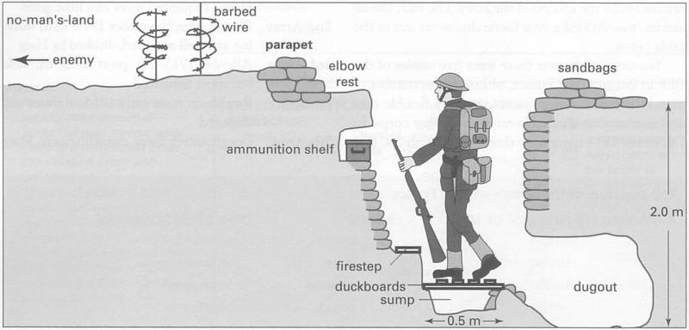

- Artillery became more powerful – huge guns would bombard enemy trenches with shells from miles away. This killed more soldiers than any other weapon
- Machine guns – were used to mow down advancing enemy soldiers when they went ‘over the top’ into ‘no man’s land’. This was area between trenches and included barbed wire, sandbags and lots of shell holes off exploding shells. Attacks were signalled with whistles and soldiers were expected to walk towards the enemy with heavy equipment, leading to huge disasters (e.g. the Somme)
- Trench Life – soldiers mostly waited for attacks, not actually fighting, they were often bored and would have to ‘stand to’ every morning and evening. Jobs would include delivering messages, repairing trenches and cleaning equipment. Food was boring (bully beef, barkers, bung, biscuits etc.) and soldiers often wrote letters or poems to pass the time. Soldiers had to deal with awful conditions (e.g. rats, lice, poor hygiene, trenchfoot, shellshock etc).
Defence of the Realm Act (DORA), August 1914
- Personal restrictions. You could not: write letters in code, no using a camera without a permit, lighting bonfires, ringing church bells, buying binoculars, feeding bread to dogs and horses.
- This was to ensure that civilian actions were controlled and any actions that might benefit the enemy or damage the war effort were stopped. The government also feared that German spies were in Britain, which is why measures on binoculars, cameras and code writing were introduced.
- More serious were restrictions on hoarding food and profiteering (stopping black markets)
- British Summer Time was introduced in 1916 so that farmers could spend longer working in the fields

Censorship
- This gave the government the powers of censorship throughout the war.
- Only news issued by GHQ (army headquarters) or government departments could be published.
- Letters sent to and from the Western Front were censored and checked by censors.
- Maintain morale at home. Censorship was to ensure that the public did not find out about the worst features of war e.g. heavy casualties, poor living conditions.
- Letters or newspaper articles might give classified military information to enemy so needed to be censored

Propaganda
- Government used propaganda in the early months to ensure support for the war effort and to encourage young men to volunteer. They also used to encourage Home Front to be strong, support war and show enemy we weren’t scared.
- Exaggerated enemy features to make the enemy appear even worse.
- Methods included posters and from 1915 films were made to encourage support for the war effort, and in 1916 the Battle of the Somme film was shown in cinemas all over Britain (much of this film was staged)

Home Front
DORA  1914 | Personal restrictions: censorship, daylight savings time
Censorship | Government powers to censor/hide information. Only letters by GHQ/ government could be published. Letters censored.
Propaganda | Boost morale. Communicate messages e.g. rationing. To recruit soldiers and female workers.
Rationing  1.1.1918 | German unrestricted submarine warfare – Britain 6 weeks from starving out. Sugar rationed, then tea, jam and butter. Ration cards
Increased female employment | Munitionettes – munitions workers, nickname canary girls.  Land Girls – 13,000  Transport workers.  Engineers and mechanics.  1.2 million joined - start of war.
Contract workers  (additional labour) | Empire -100,000 Egyptians, tens thousands Indians.  Other workers: Chinese workers 100,000, refugees - Birtley Belgians
Total war | Zeppelin raids – 57 in 1915. Whitby, Hartlepool.  Gotha bombers 1917.  Defensive measures: barrage balloons, underground shelters

Treaty of Versailles
Germany
Big Three
Clemenceau – France | Wanted to punish Germany harshly. Wanted security for Germany. Wanted reparations
Lloyd-George - Britain | Wanted to punish Germany in some way, but also for them to recover enough to trade with.
Wilson - USA | Idealist. Wanted a lasting peace

The Treaty of Versailles
War Guilt Clause | Germany to accept all blame for the war
Reparations | Pay damages to victorious powers. £6.6 billion
Land Loss | West: Alsace and Lorraine  East: Port of Danzig, Polish Corridor  Lost 11 colonies
Military restrictions | Army: 100,000, no conscription.  Navy: 15,000, no submarines, 6 battleships
League of Nations | Not allowed to join the League of Nations
German reactions to the Treaty of Versailles
Diktat | Dictated terms of the treaty. All of Germany’s objections were ignored.
Dolchstoss | ‘Stab in the back.’ Germany army felt Weimar Government politicians had stabbed them in the back by ending the war
November Criminals | Negative name given to the Weimar Government for agreeing to the armistice

Dictators
- You have studied 5 dictators this year and will need to think about the impact they had on the world over the last century
- Think about the following information and what the result of each dictatorship could mean for people affected?

Mussolini
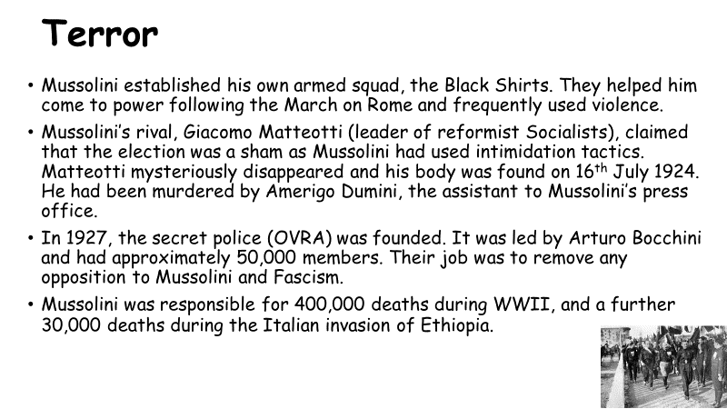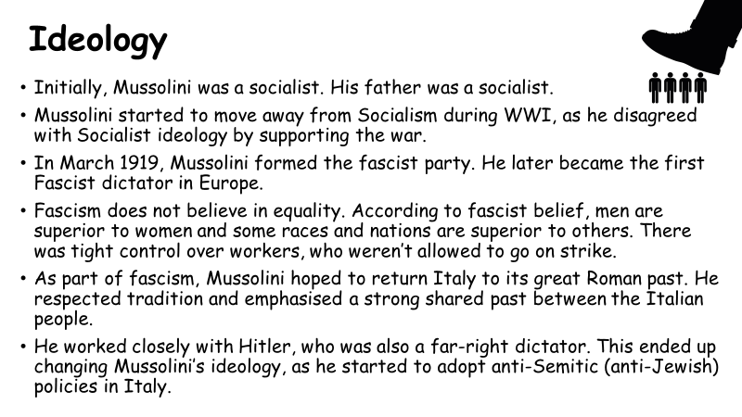
Stalin
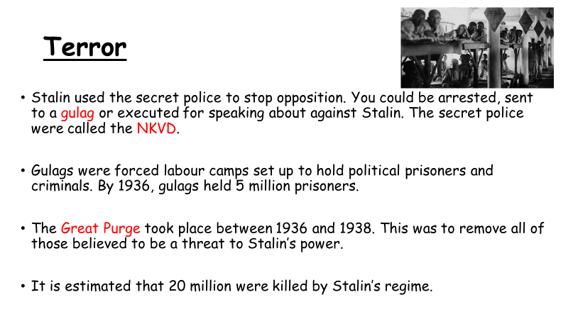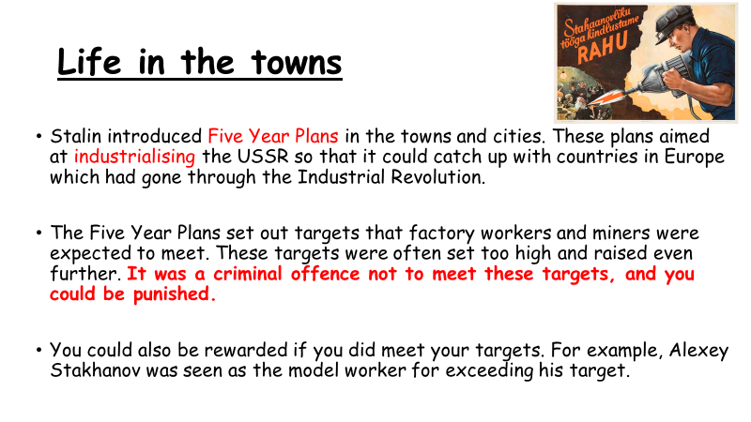
Hitler
