Year 9 – Composing your own song – Part 1
BBC Bitesize – KS3 website

Open the link below
https://www.bbc.co.uk/bitesize/topics/z3dqhyc
Click on the How to write a song section. 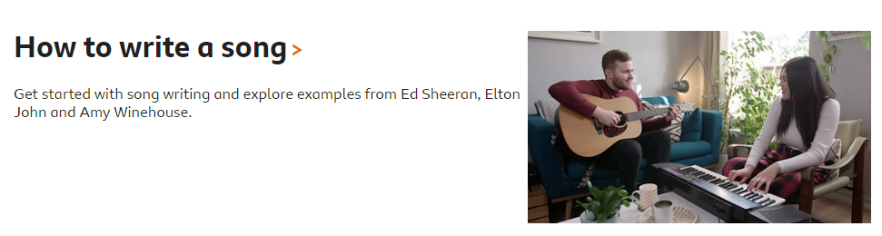
Watch the video
Watch and listen to the three examples of lyrics and read what the key sections of the song.
Complete the quiz at the bottom of the page.
Listen to the chord sequence using the section on the page.
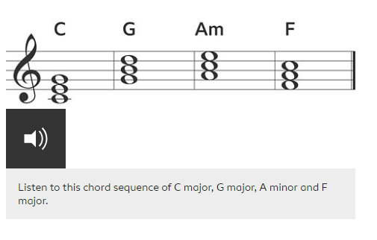
Using the virtual piano on https://www.musicca.com/piano
TASK - Try and come up with a chord sequence following the ideas shown below.
Choose 4 chords from the list below – start on C – you can end on any chord
C= CEG Dm = DFA Em = EGB F=FAC G=GBD Am= ACE
Mr Robinson’s Chord sequence example - e.g. C G Am G
Create a second chord sequence that has 4 chords and ends on G.
Mr Robinson’s Second Chord Sequence example – e.g. F C F G
Repeat your first line.
Last line Chord I ?? Chord II ?? Chord 3 = G and Chord 4 = C (which will make sequence sound finished.
Mr Robinson’s chord sequence
Line 1 C G Am G
Line 2 F C F G
Line 1 repeated C G Am G
Last line F C G C

Notes of chords (you have to play all three notes using your virtual piano (https://www.musicca.com/piano)
C= CEG Dm = DFA Em = EGB F=FAC G=GBD Am= ACE
Using WORD note down some possible ideas and save them in your documents as Song Writing 1 Chords

