St Bede’s Catholic School & Byron Sixth Form College

**Headteacher : Mrs F Cessford**

Westway, Peterlee, Co Durham, SR8 1DE

0191 587 6220

@StBedesandByron [enquiries@st-bedes.org](mailto:enquiries@st-bedes.org) [www.st-bedes.org](http://www.st-bedes.org/)

**‘ Be who God meant you to be and you will set the world ablaze’**



**FAITH, RESPONSIBILITY, EXCELLENCE, DETERMINATION, CITIZENSHIP, RESPECT**

Dear Parent / Guardian,

# Geography trip to Iceland, 22nd - 25th February 2026

We are delighted to confirm the details for the Iceland field trip next February. We have confirmed flights departing from and returning to **Newcastle Airport**.

The current cost of the trip is **£1055 (16 and over)** and **£1042 (15 and under)**. The cost includes flights, transport in Iceland, all activities, full board meals and accommodation. This £80 increase is due to the fact that we are taking slightly less students than initially planned, meaning the cost per student has increased. We have also upgraded our lagoon experience to an infinity lagoon (The Sky Lagoon) and increased the amount of activities included in each day so that students can get the most of this experience. This price also includes the coach to and from Newcastle airport. We have also been able to change the date the 2nd deposit of £110 is due to the 14th May, instead of the end of April.

Please see below the details:

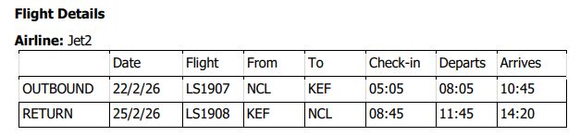

|  |  |
| --- | --- |
|  | Tour Details |
| Tour Inclusions: | * Return flights to Iceland from **Newcastle Airport** * 3 nights’ accommodation at Hotel Ork, Iceland * Students will stay in multi-bedded rooms with en-suite facilities. * Meals on a full boardbasis * Resort coaching * Programme of activities and excursions (Including the Secret lagoon, Golden circle, capital of Reykjavik, Gulfoss Waterfall, volcanic geysers, the South shore, Kerid crater amongst others) * Dedicated Field Study Tutor throughout the trip * Comprehensive Aviva Travel Insurance |
| Cost | **£1,055** per person (over 16) **£1042** (15 & under)  This difference is due to the Air Passenger Duty tax, that is applicable for students aged 16 and over at the time of travel. |
| Payments and due dates: | Second deposit **£110 (Wednesday 14th May 2025)**  The remaining full balance is due 10 weeks prior to departure (**Monday 8th December 2025**)  Please continue to use Parent Pay / cash via the main office to break the amount down into instalments. |
| Travel requirements: | All pupils require a current passport. Please ensure passport is valid for six months after date of return. If your child needs a new passport please leave plenty of time for this to arrive. Failure to have an up to date passport will prevent them from coming on the trip, regardless of money been paid. Please ask your child to bring a photo of their passport information, i.e. passport number, if they have not done so already. Passport applications: <https://www.gov.uk/browse/abroad/passports> |

## Information evening

We will be holding an information evening to provide further trip details and answer any questions. A letter confirming when this is will follow.

Yours faithfully,



Mrs E Martin

Head of Geography

